International Cybersecurity and Digital Forensics Academy (ICDFA)
CIP-B102 Foundations of Computer and Digital Forensics
Lab 6: Data Carving with xxd, Binwalk and Scalpel
Forensic Lab Report
Item | Details
Student Name | Fuseini Imoru Kantuogaa
Registration Number | C11/26/DFIT/17291
Instructor’s Name | Dr. Sarah James
Course Code | CIP-B102
Lab Number | Lab 6
Date Submitted | July 12, 2026
Working Environment | Kali Linux (kali@kali), working directory ~/CIP-B102_Lab6_Data_Carving

1. Objective
The purpose of Lab 6 is to develop practical digital forensic skills in data carving: recovering files and file fragments when normal file-system metadata is missing, damaged, or unreliable. This lab uses xxd to inspect binary content and file signatures at the byte level, The Sleuth Kit (TSK) to examine FAT file-system structures and recover files by inode, binwalk to detect and extract embedded file signatures inside container files, and scalpel to carve deleted files directly from a raw USB image using header/footer signatures. The exercise reinforces the difference between normal file recovery through metadata and true data carving from unallocated or unreferenced space, and it documents every command, output, hash value, and finding needed to reconstruct the analysis.

2. Tools and Environment
Tool | Version / Notes | Use in this Lab
OS / VM | Kali Linux (kali@kali) | Forensic working environment for all commands
xxd | Kali default build | Hex dump and reverse hex dump of the JPEG sample
The Sleuth Kit | img_stat, mmls, fsstat, fls, istat, icat | Direct inode/sector-level examination of FAT images
binwalk | Kali default build | Detection/extraction of embedded file signatures
scalpel | v1.60 (based on Foremost 0.69) | Header/footer based carving of deleted files from the USB image
7z / p7zip | 7-Zip 26.01 (x64) | Extraction of the downloaded 120M.7z archive
md5sum / sha256sum | coreutils | Integrity verification before and after extraction
Working directory: ~/CIP-B102_Lab6_Data_Carving (created for this lab and used for every command below).

3. Evidence Sources
The following files were downloaded exactly as specified in the Data Carving slide material and used unmodified as evidence throughout the lab.
File | Source URL | Purpose
Ch01InChap01.dd | https://www.dropbox.com/s/nw23q14vzsykyup/Ch01InChap01.dd | FAT12 image for TSK inode/sector-level demonstration
J_ub_law.jpg | raw.githubusercontent.com/.../usb_file/J_ub_law.jpg | xxd header/tail signature analysis and hexdump reconstruction
120M.7z | raw.githubusercontent.com/.../usb_image/120M.7z | Deleted-file carving with scalpel after extraction

3.1 Hash Values of Downloaded Evidence
File | MD5 | SHA-256
Ch01InChap01.dd | a117773bcf1fc88ec0ab8e0a349fbbcb | 3ce8053e4f3d9c8ab98b3aadb2480685efb8e4980d34297b83bd5a09b1a7b122
J_ub_law.jpg | 83a360ac7f7e0ca318e5bfe39f95f137 | 238ff34393c50e52c0e8b14fcff8ec7dc29e23914dbc435f8ef998d172a91468
120M.7z | dfe7b5424e54cd1bf50d5df47aceeb3c | 2d2a3d93c9ec65bcad9f89c9894429ea72caa8add07726a3b96ec9a0ab6a58ce
(Hash values transcribed from the command output shown in Figure 3; refer to that screenshot as the authoritative source.)
4. Procedure

4.1 Preparation: Working Folder and Downloads
A dedicated working directory was created and the three evidence files were downloaded with wget, then verified by file type, size, and hash.
mkdir -p ~/CIP-B102_Lab6_Data_Carving cd ~/CIP-B102_Lab6_Data_Carving wget -q <Ch01InChap01.dd URL> -O Ch01InChap01.dd wget -q <J_ub_law.jpg URL> -O J_ub_law.jpg wget -q <120M.7z URL> -O 120M.7z
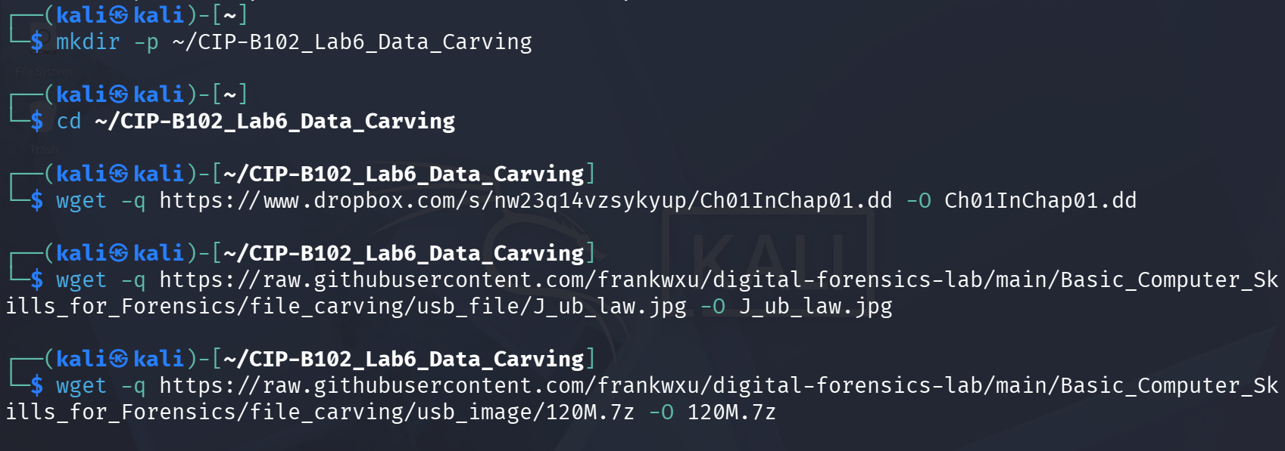
Figure 1. Working directory created and the three evidence files downloaded with wget.
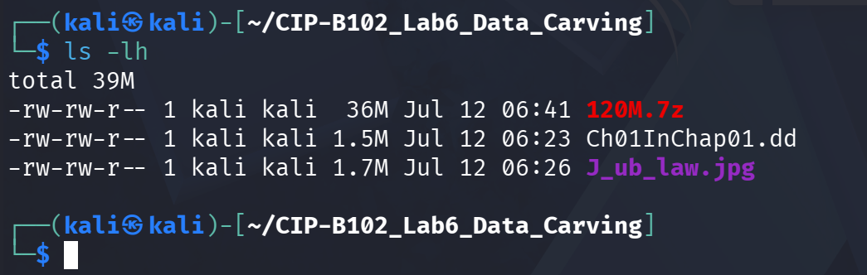
Figure 2. Directory listing (ls -lh) confirming all three files downloaded successfully.
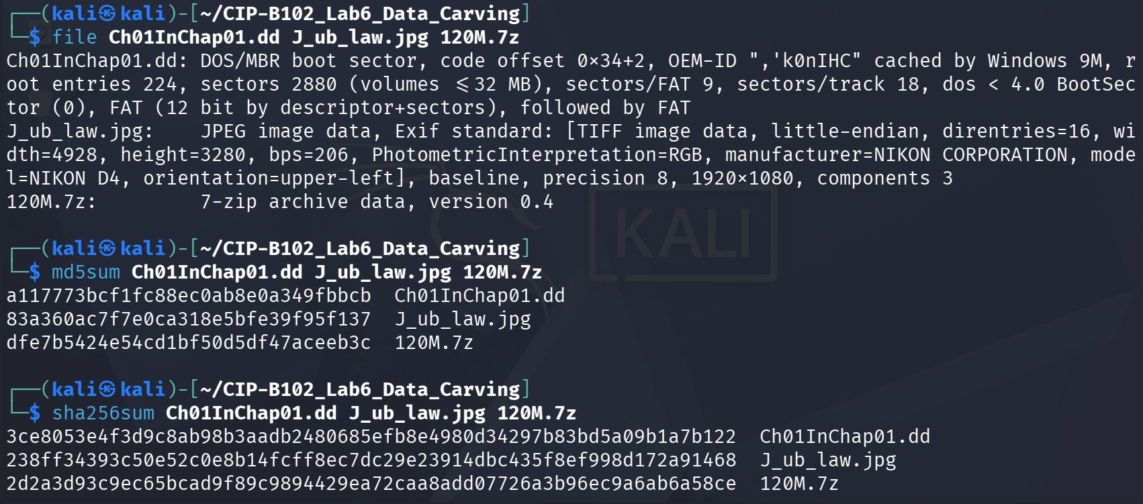
Figure 3. file, md5sum, and sha256sum output identifying each file type and recording baseline hash values.

4.2 Part A: File Metadata vs. Data Carving (Conceptual)
Retrieving a file through file-system metadata means the file system's directory entries and allocation tables (e.g., the FAT) still point to valid, allocated data for that file, so the OS can locate and read it directly by name. Data carving instead ignores file-system metadata entirely and scans the raw bytes of a device or image for header signatures (e.g., 0xFFD8 for a JPEG's Start of Image, SOI) and footer/tail signatures (0xFFD9 for JPEG End of Image, EOI), extracting everything in between as a candidate file. This works even when a directory entry has been deleted or damaged, because the underlying data may still exist in sectors/blocks that the file system no longer marks as allocated (unallocated space) until it is overwritten.
Answers to the required questions:
- A deleted file can still be partially or fully recoverable because deleting a file typically removes or marks its directory entry and FAT chain as free, but the actual data in the associated clusters is not erased until those clusters are reused and overwritten by new data.
- A file name can be lost even when content is recovered because the name lives in file-system metadata (the directory entry), while the content lives in data blocks/clusters. Carving tools that scan for header/footer signatures recover the byte content but have no metadata to read the original name from, so carved files are typically given generic sequential names.
- Normal file recovery reads a file through intact, valid file-system metadata (directory entry + allocation table); data carving reconstructs files purely from recognizable byte patterns in raw data, independent of whether any metadata for that file still exists.
- The JPEG markers used to bound a file are SOI (Start of Image) 0xFFD8 at the beginning and EOI (End of Image) 0xFFD9 at the end.

4.3 Part B: Examining the JPG with xxd
xxd J_ub_law.jpg | head xxd J_ub_law.jpg | tail xxd -l 120 J_ub_law.jpg xxd -p J_ub_law.jpg > J_ub_law_hexdump.txt grep -o "ffd8" J_ub_law_hexdump.txt | head grep -o "ffd9" J_ub_law_hexdump.txt | tail xxd -p J_ub_law.jpg | tr -d "\n" > J_ub_law_hexdump_singleline.txt grep -o "ffd8" J_ub_law_hexdump_singleline.txt grep -o "ffd9" J_ub_law_hexdump_singleline.txt
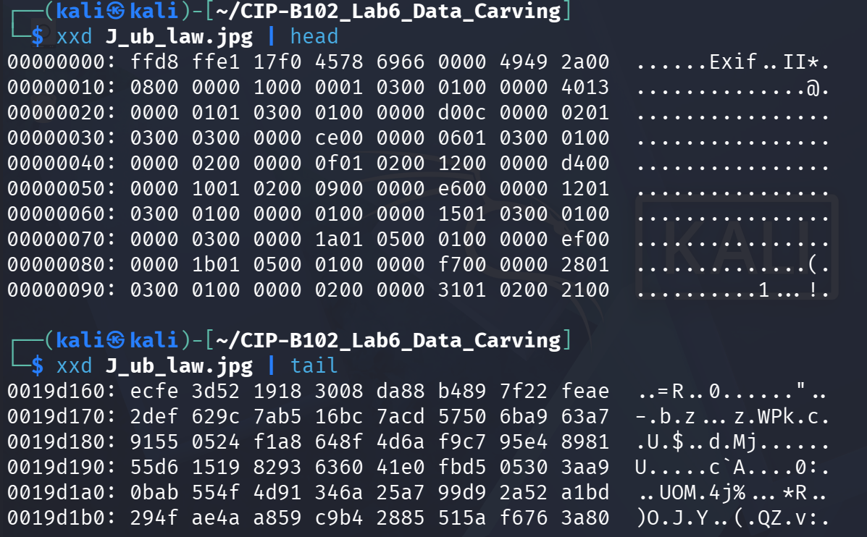
Figure 4. xxd J_ub_law.jpg | head and | tail, showing the ffd8 SOI marker at the very start of the file and unstructured compressed data at the end.
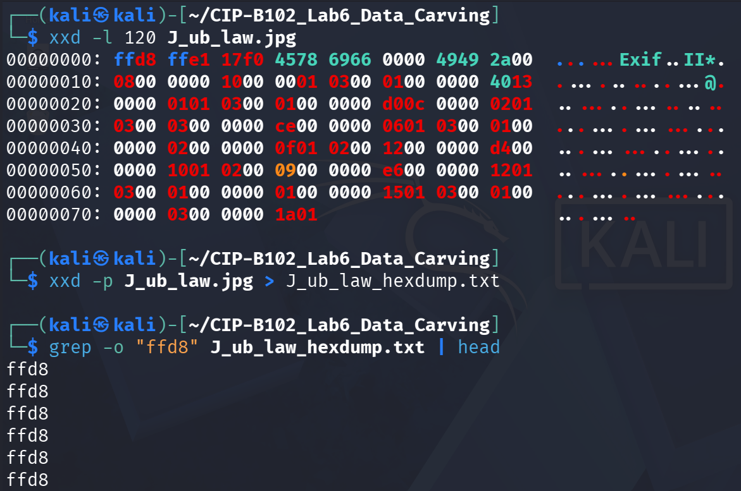
Figure 5. xxd -l 120 showing the first 120 bytes and the beginning of the plain hexdump generation (xxd -p).
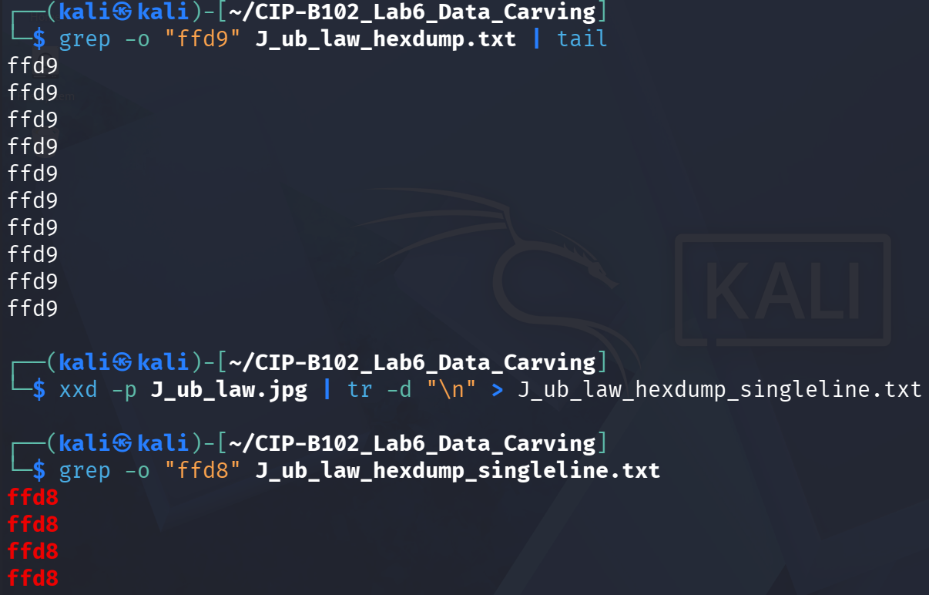
Figure 6. grep search for the ffd9 tail signature in the plain hexdump, and creation of a single-line (no newline) hexdump so signatures are not split across line breaks.
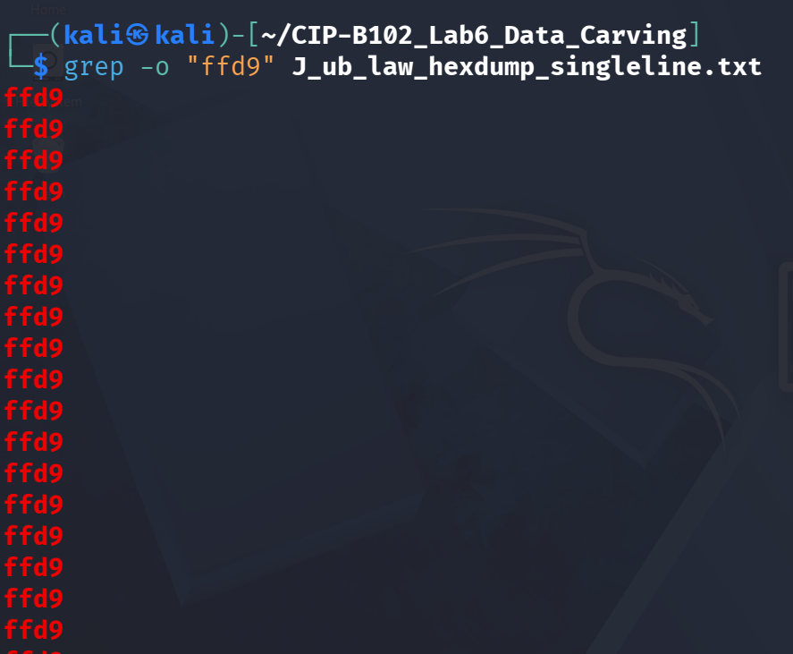
Figure 7. Continued search for the ffd9 footer signature across the single-line hexdump.
The single JPEG in this sample only contains one true SOI (0xFFD8) at offset 0 and one true EOI (0xFFD9) at the very end of the file; the additional ffd8/ffd9 matches returned by grep on the raw (non single-line) hexdump are coincidental byte patterns inside the compressed image data and metadata, which is why the single-line search is the more reliable check for the true header/footer boundary.
The plain hexdump was then converted back into a binary JPEG using xxd -r -p, and the reconstructed file was compared against the original by hash to confirm the round-trip was lossless.
xxd -r -p J_ub_law_hexdump.txt J_ub_law_reverse_dump.jpg file J_ub_law_reverse_dump.jpg md5sum J_ub_law.jpg J_ub_law_reverse_dump.jpg sha256sum J_ub_law.jpg J_ub_law_reverse_dump.jpg
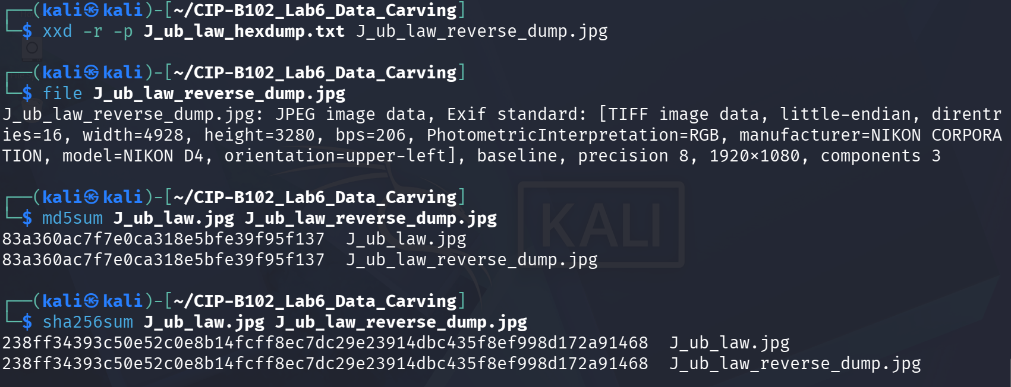
Figure 8. Reverse hexdump reconstruction (xxd -r -p) and hash comparison: J_ub_law.jpg and J_ub_law_reverse_dump.jpg produced identical MD5 and SHA-256 values, confirming an exact reconstruction.
Expected observation confirmed: the MD5 (83a360ac7f7e0ca318e5bfe39f95f137) and SHA-256 hash of the original and the reverse-dumped file matched exactly.

4.4 Part C: Metadata-Like Strings Inside the JPG
xxd -s 0x100 -l 0x9f J_ub_law.jpg strings J_ub_law.jpg | head -50 strings J_ub_law.jpg | grep -Ei "nikon|photoshop|adobe|date|copyright|author|name"
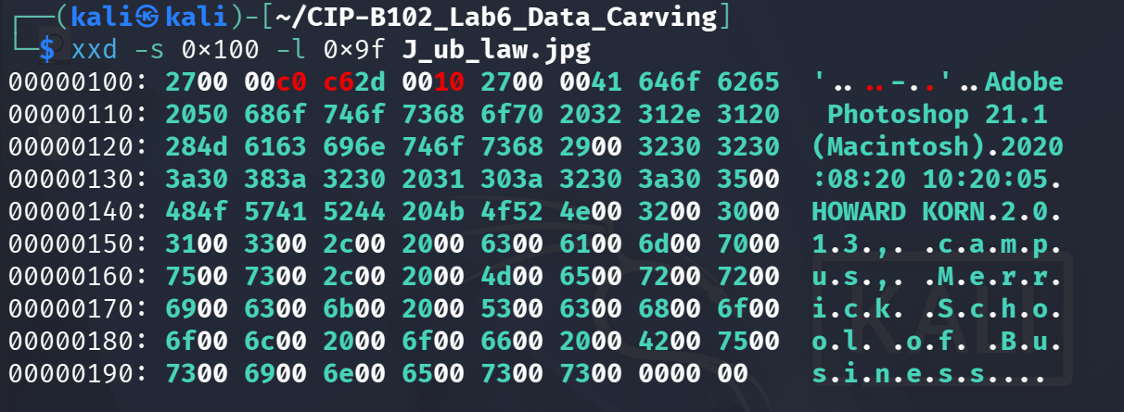
Figure 9. xxd -s 0x100 -l 0x9f showing the metadata region of the JPEG, including readable Adobe/Photoshop and author-related text.
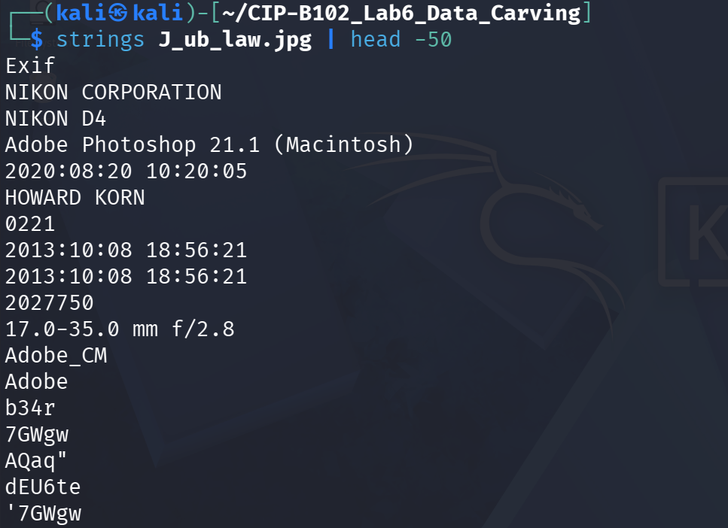
Figure 10. strings output (first 50 lines) revealing camera make/model, editing software, and embedded dates.
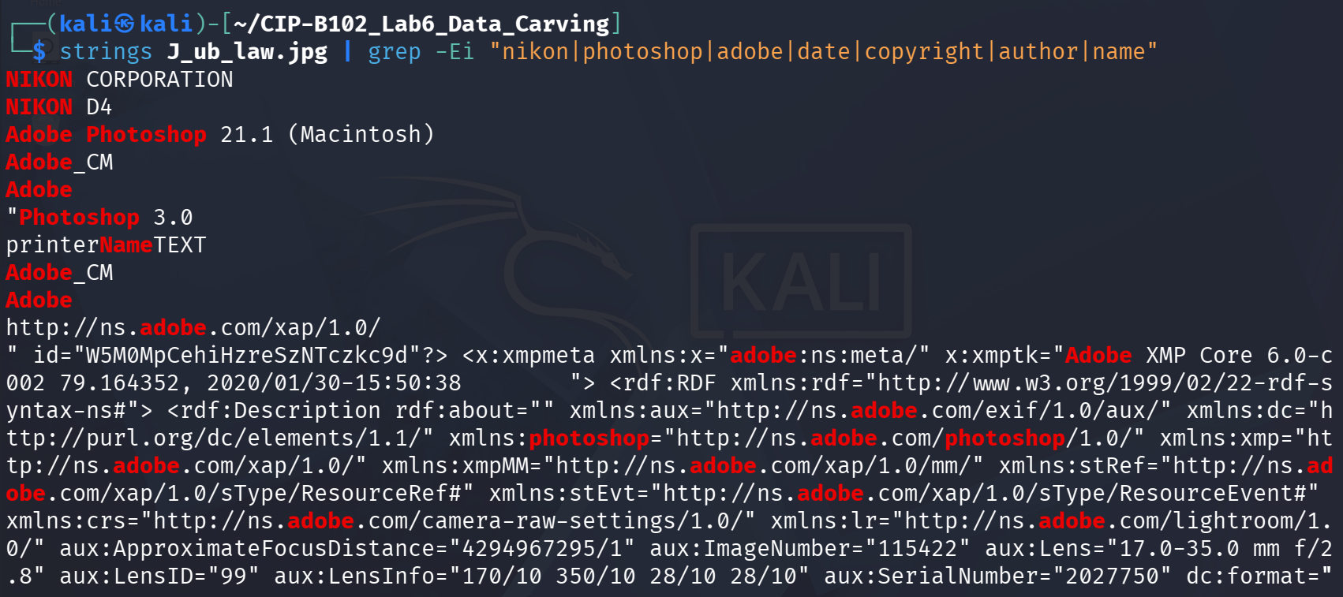
Figure 11. Filtered strings search (grep -Ei) isolating camera, software, and copyright-related identifiers.
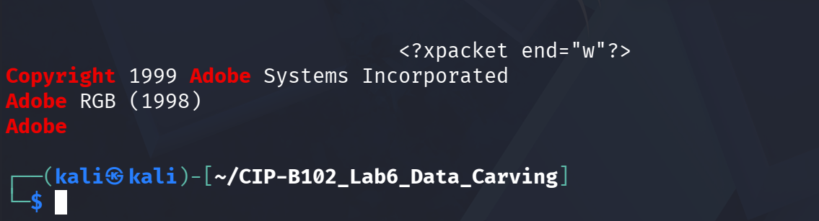
Figure 12. Continued filtered strings output, including the embedded 'Copyright 1999 Adobe Systems Incorporated' string and Adobe RGB colour-profile reference.
Strings/metadata found in J_ub_law.jpg:
Field | Value Found | Notes
Camera manufacturer | NIKON CORPORATION | From embedded Exif/TIFF tags
Camera model | NIKON D4 | From embedded Exif/TIFF tags
Editing software | Adobe Photoshop 21.1 (Macintosh) | From Photoshop/XMP metadata block
Software-recorded date | 2020:08:20 10:20:05 | Photoshop edit timestamp
Name string | HOWARD KORN | Plain-text name found via strings
Lens | 17.0-35.0 mm f/2.8 | From XMP aux:Lens tag
Copyright | Copyright 1999 Adobe Systems Incorporated | Embedded copyright string, also flagged by binwalk
Original capture date | 2013:10:08 18:56:21 | EXIF DateTimeOriginal-style field

4.5 Part D: Direct Data-Unit Access in the DD Image with TSK
img_stat Ch01InChap01.dd mmls Ch01InChap01.dd fsstat Ch01InChap01.dd | head -40 fls Ch01InChap01.dd fls -d Ch01InChap01.dd
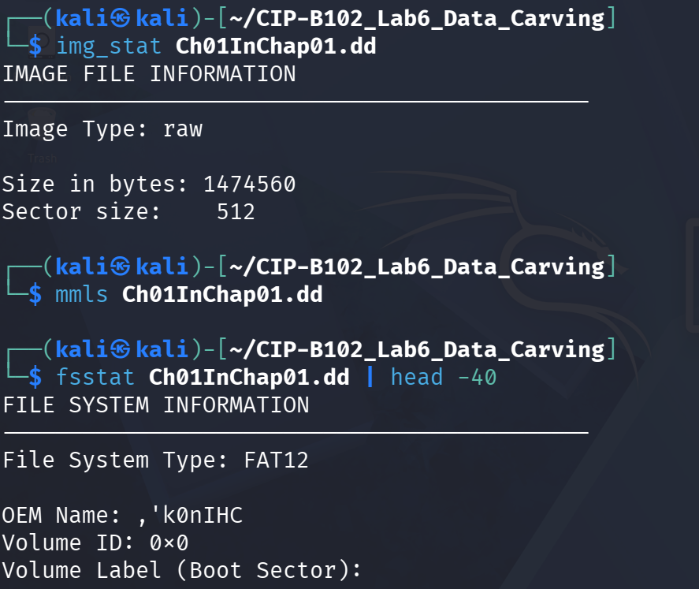
Figure 13. img_stat and the start of fsstat output: raw image, 1,474,560 bytes, 512-byte sectors, FAT12 file system.
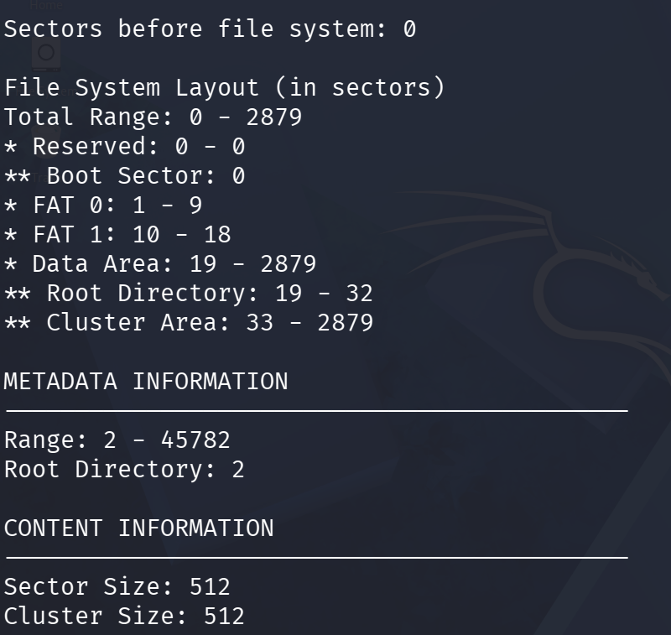
Figure 14. fsstat file-system layout: reserved area, two FAT copies (sectors 1-9 and 10-18), root directory and data/cluster area (sectors 19-2879).
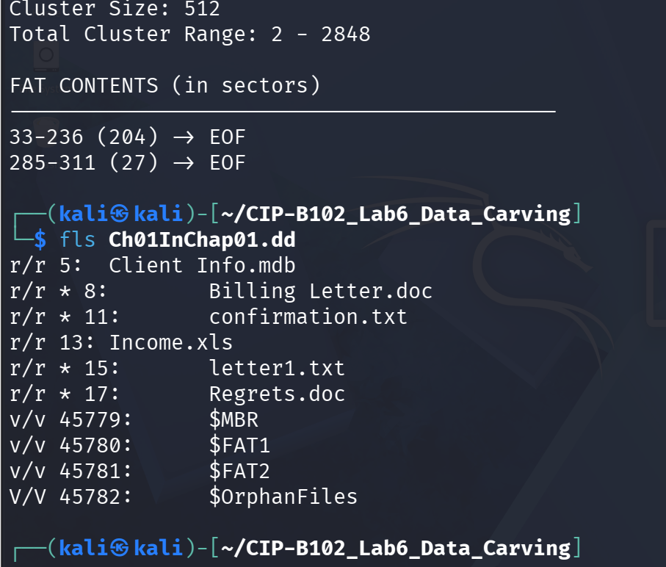
Figure 15. fsstat FAT chain summary and fls listing of the root directory, showing allocated and deleted (marked *) entries.
fls confirmed six file entries in the root directory, four of which are marked with * (unallocated / deleted): Billing Letter.doc (8), confirmation.txt (11), letter1.txt (15), and Regrets.doc (17). Client Info.mdb (5) and Income.xls (13) remained allocated.
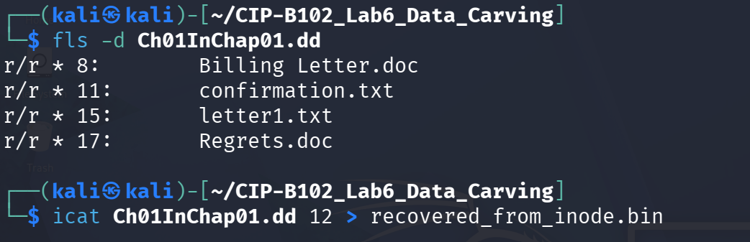
Figure 16. fls -d isolating only the deleted entries, followed by the start of icat recovery using the inode/entry number.
icat was used to recover file content directly from the inode/entry numbers identified above, and the recovered files were verified with file:
icat Ch01InChap01.dd 8 > Billing_Letter.doc file Billing_Letter.doc icat Ch01InChap01.dd 11 > confirmation.txt file confirmation.txt icat Ch01InChap01.dd 15 > letter1.txt file letter1.txt
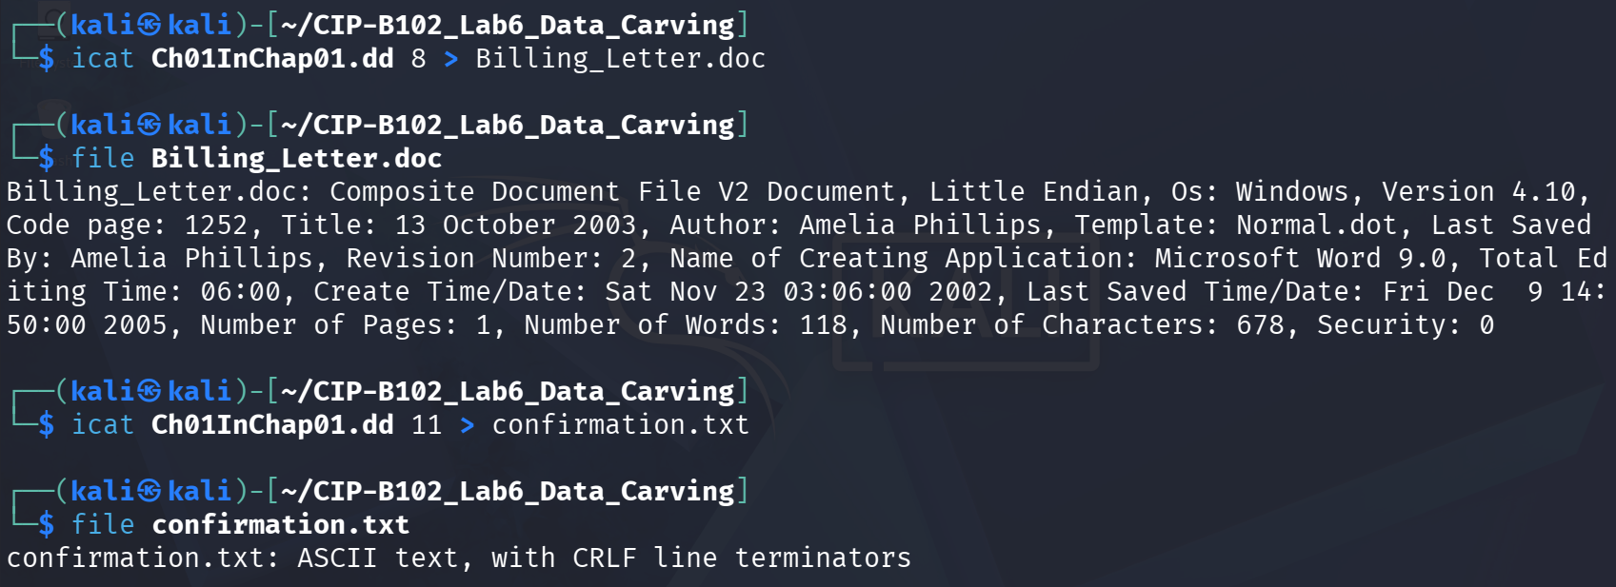
Figure 17. icat recovery of entry 8 (Billing_Letter.doc), confirmed by file as a genuine MS Word 9.0 document with embedded author metadata (Amelia Phillips); icat recovery of entry 11 (confirmation.txt).
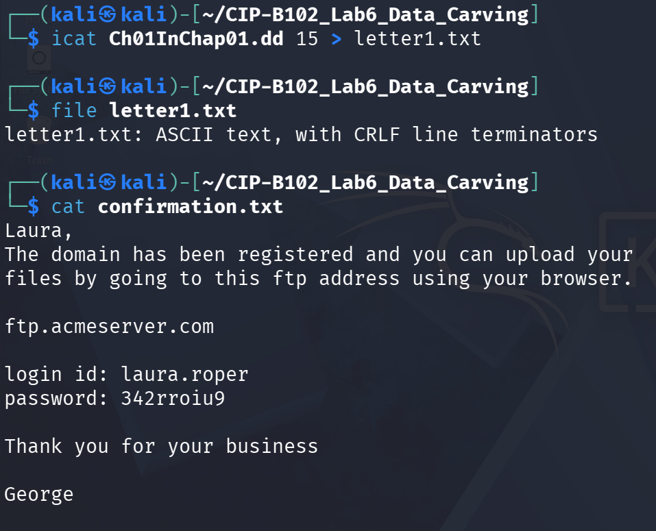
Figure 18. icat recovery of entry 15 (letter1.txt) and the recovered content of confirmation.txt, an FTP login handoff message.
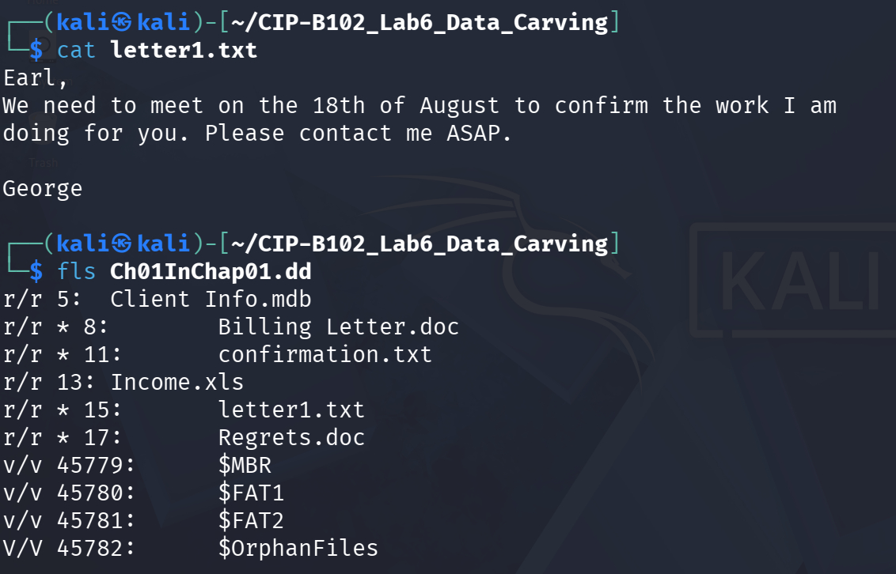
Figure 19. Recovered content of letter1.txt (a short meeting-reminder message) and a repeat of the fls listing for reference.
Recovered file contents:
Recovered File | Content Summary
confirmation.txt | Message from 'George' to 'Laura' providing an FTP address, login ID (laura.roper) and password (342rroiu9) for uploading files.
letter1.txt | Short note from 'George' to 'Earl' about meeting on the 18th of August to confirm work in progress.
istat was then used against each deleted entry to record its metadata (size, name, timestamps, and sector allocation) directly from the directory entry, independent of whether the entry is still marked allocated:
istat Ch01InChap01.dd 8 istat Ch01InChap01.dd 11 istat Ch01InChap01.dd 15 istat Ch01InChap01.dd 17
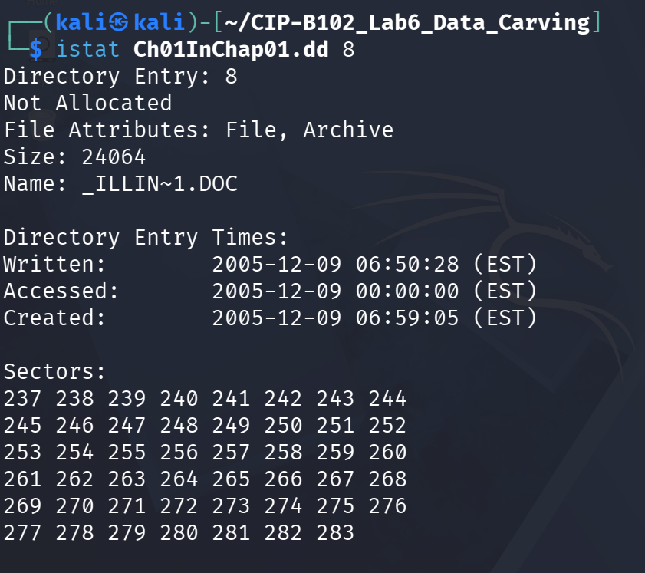
Figure 20. istat for entry 8: _ILLIN~1.DOC (Billing Letter.doc), 24,064 bytes, not allocated, with full written/accessed/created timestamps and its sector run (237-283).
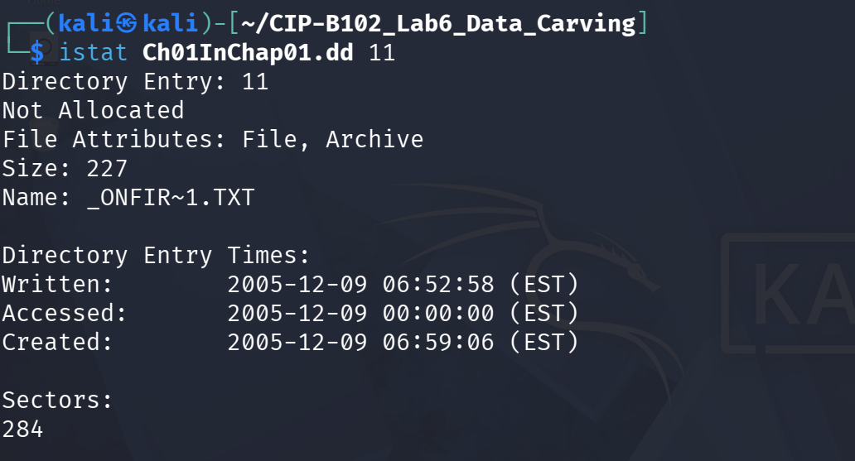
Figure 21. istat for entry 11: _ONFIR~1.TXT (confirmation.txt), 227 bytes, not allocated, single sector (284).
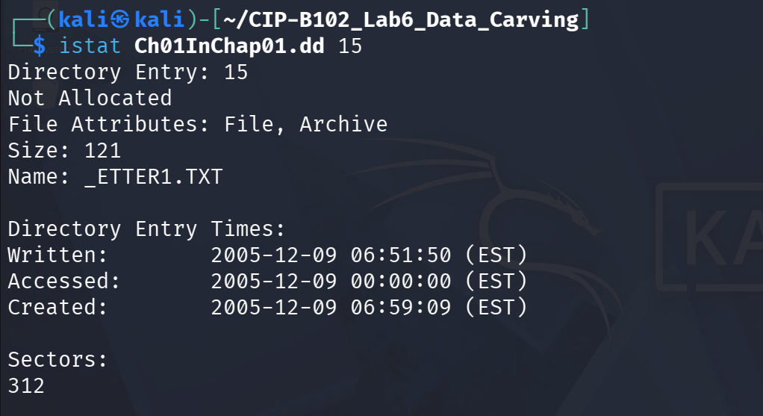
Figure 22. istat for entry 15: _ETTER1.TXT (letter1.txt), 121 bytes, not allocated, single sector (312).
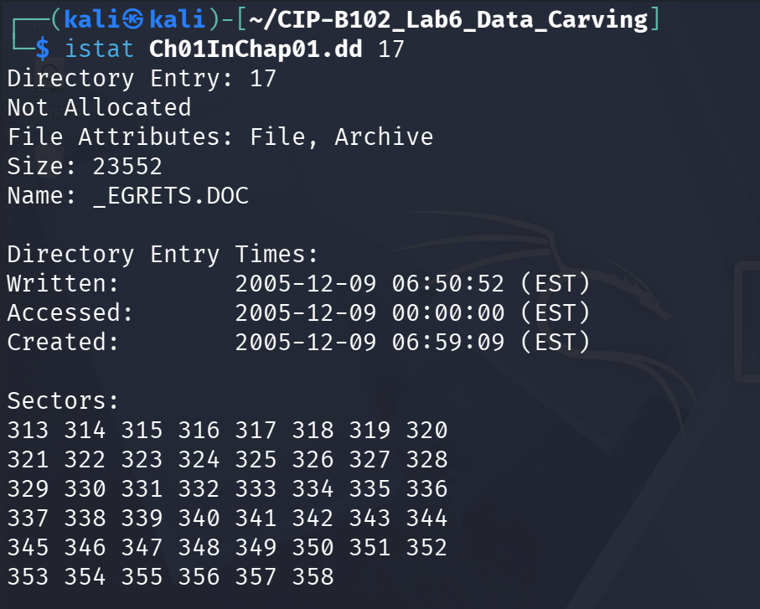
Figure 23. istat for entry 17: _EGRETS.DOC (Regrets.doc), 23,552 bytes, not allocated, sector run (313-358).
Note: TSK still displays a name for each of these entries (e.g., _ILLIN~1.DOC) because the short 8.3 directory entry itself was still present and only flagged as 'not allocated' this is a metadata-assisted recovery, not true header/footer carving, which is why names and timestamps were still available here but were not available later for the scalpel-carved JPEGs.

4.6 Part E: Embedded File Discovery with Binwalk
The slide's manual dd-based extraction example depends on an instructor-provided File_carving.docx, which was not included among the slide's download URLs and was not available in this environment (confirmed by ls: cannot access 'File_carving.docx'). Per the lab instructions, the binwalk practice was therefore completed using J_ub_law.jpg and 120M.7z instead.
ls -lh File_carving.docx # not available binwalk J_ub_law.jpg file J_ub_law.jpg
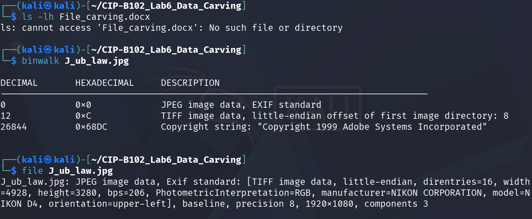
Figure 24. File_carving.docx confirmed unavailable; binwalk on J_ub_law.jpg identifying the EXIF/TIFF header at offset 0 and an embedded copyright string ('Copyright 1999 Adobe Systems Incorporated') at offset 0x68DC.
binwalk Ch01InChap01.dd binwalk -e Ch01InChap01.dd ls -lah _Ch01InChap01.dd.extracted
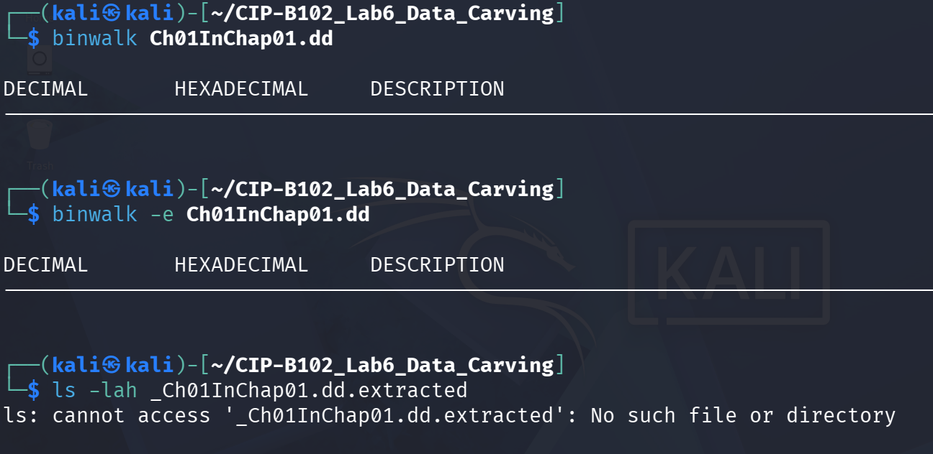
Figure 25. binwalk against Ch01InChap01.dd returned no signature matches, and binwalk -e produced no extraction folder, consistent with a plain FAT12 boot/data image containing only office documents and text files rather than any recognizable embedded container format.
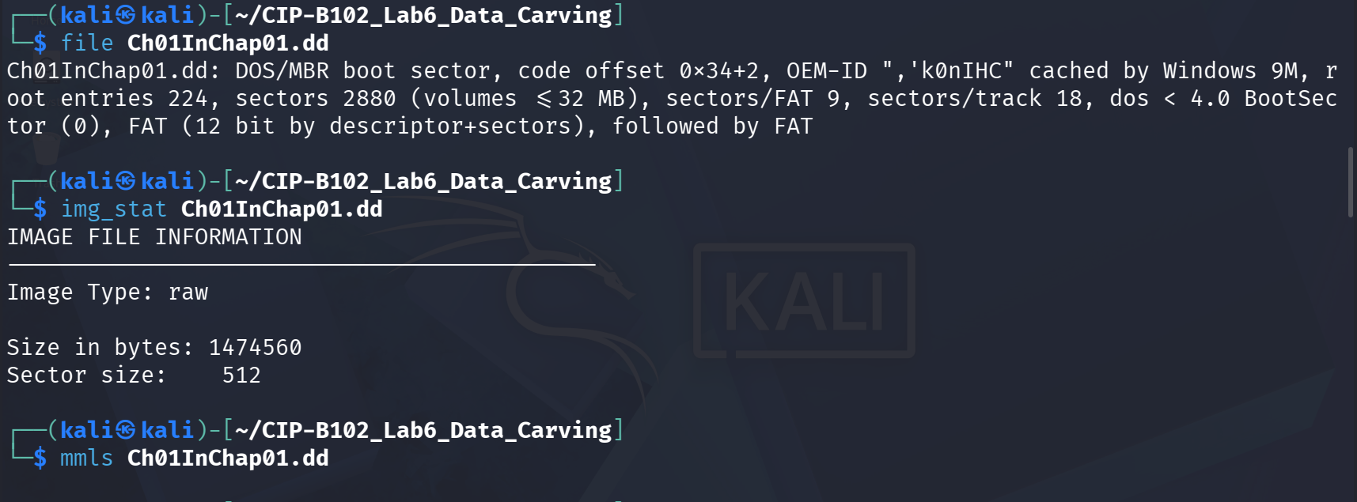
Figure 26. Re-confirmation of Ch01InChap01.dd's file type, image size, and partition table for cross-reference with the binwalk result.
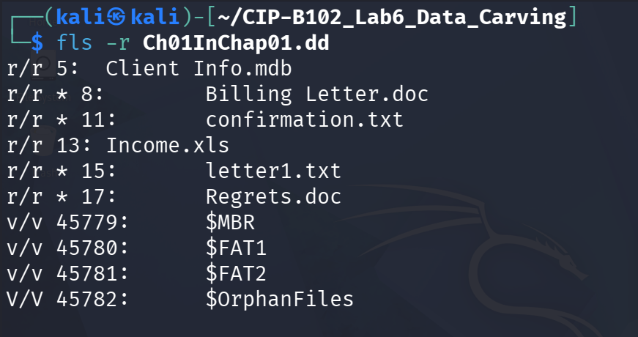
Figure 27. fls -r (recursive) listing of Ch01InChap01.dd for completeness, showing the same six entries and system metadata files ($MBR, $FAT1, $FAT2, $OrphanFiles).
binwalk 120M.7z file 120M.7z binwalk -e 120M.7z ls -lah _120M.7z.extracted
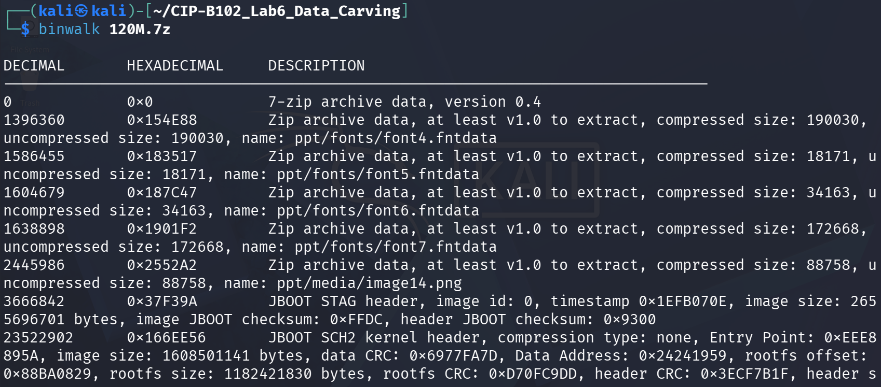
Figure 28. binwalk on 120M.7z: the true 7-zip archive header at offset 0, followed by several nested Zip archive entries (ppt/fonts/*.fntdata, ppt/media/image14.png) and JBOOT-pattern matches.
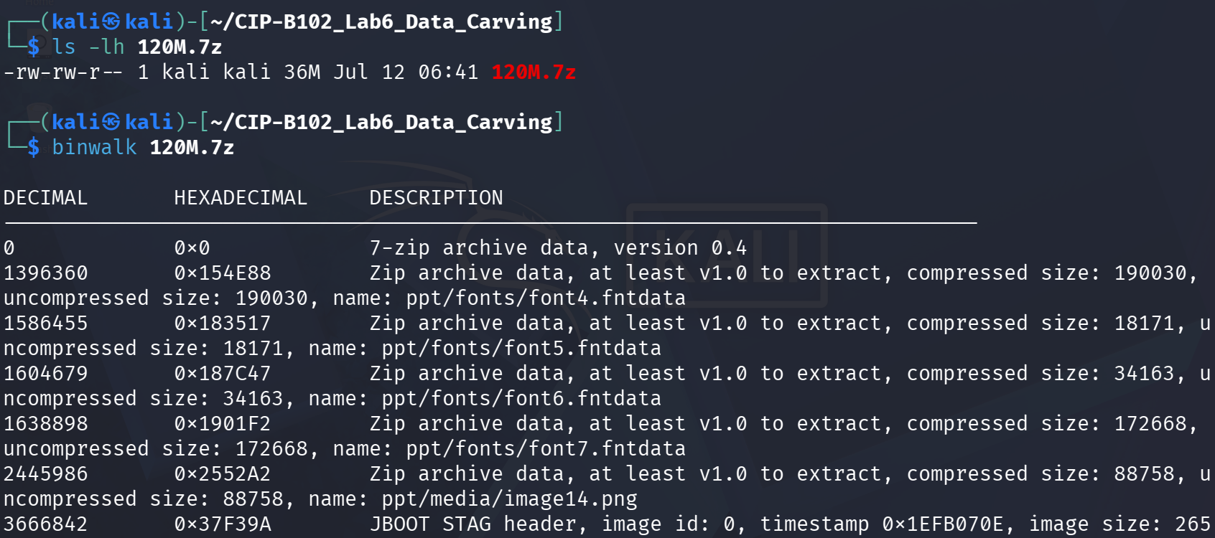
Figure 29. Continued binwalk output on 120M.7z listing further nested Zip archive/font-data signatures inside the compressed stream.
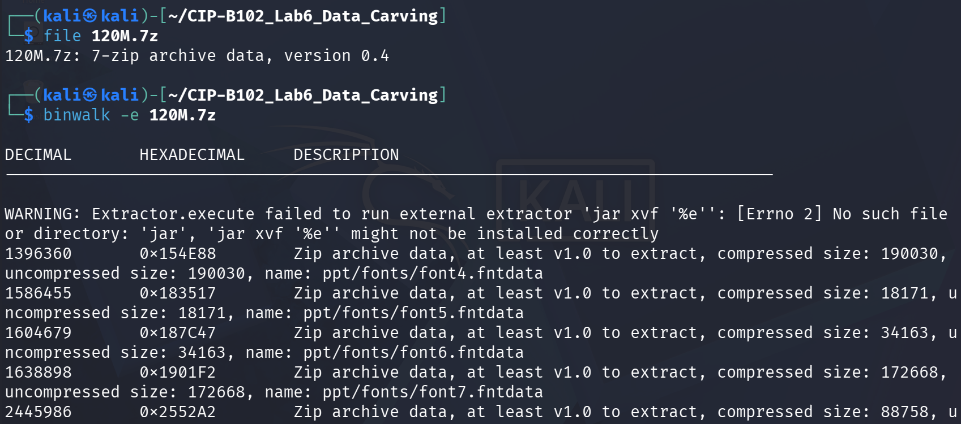
Figure 30. file confirming 120M.7z as a 7-zip archive, and binwalk -e attempting automatic extraction (the 'jar' extractor was not installed, so the JBOOT/font matches were not unpacked automatically).
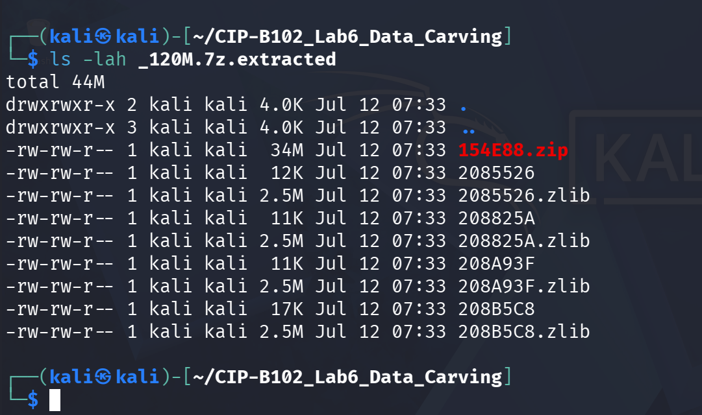
Figure 31. Contents of the partial _120M.7z.extracted folder: only a handful of small zip/zlib fragments were produced, not the full usb_fat_carving.001 image.
The PPT-font and JBOOT-style signatures reported by binwalk inside 120M.7z are false positives generated by scanning the raw compressed LZMA2 byte stream for coincidental byte patterns; they do not correspond to real embedded PowerPoint or firmware files. This was confirmed in the next step, where 7z l shows the archive's true contents are only usb_fat_carving.001 and a small companion .txt file.

4.7 Part F: Preparing and Examining the USB Image
7z l 120M.7z 7z e 120M.7z ls -lh file * | tee file_types_lab6.txt md5sum * | tee md5_after_extract_lab6.txt
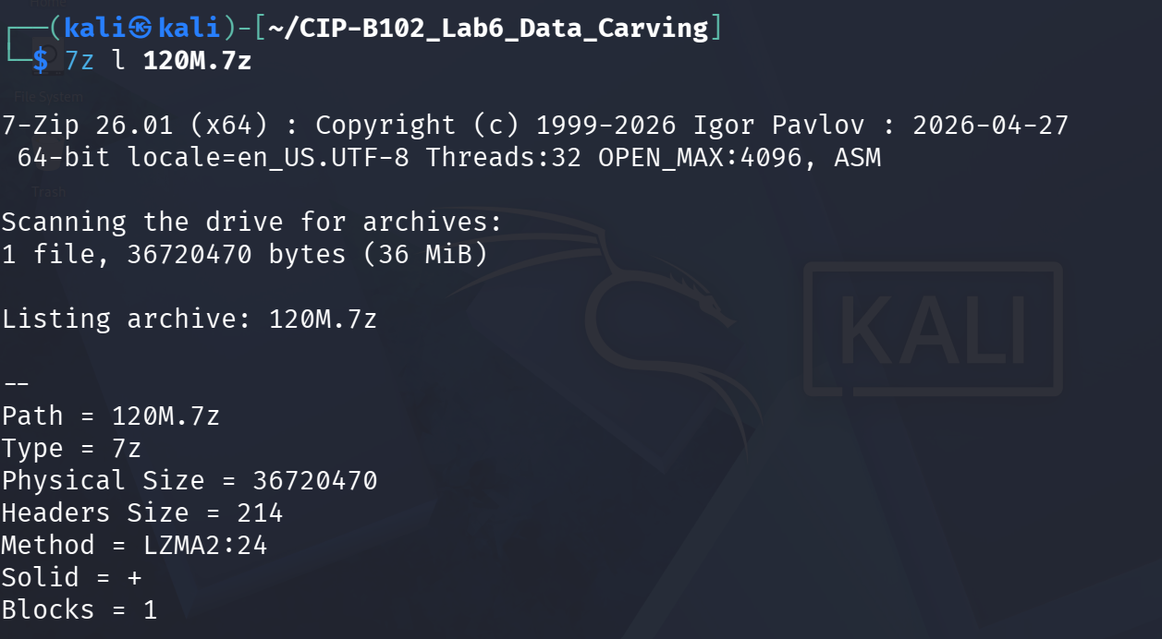
Figure 32. 7z l 120M.7z listing the archive header (7-Zip 26.01, LZMA2 method, solid archive, 1 block).
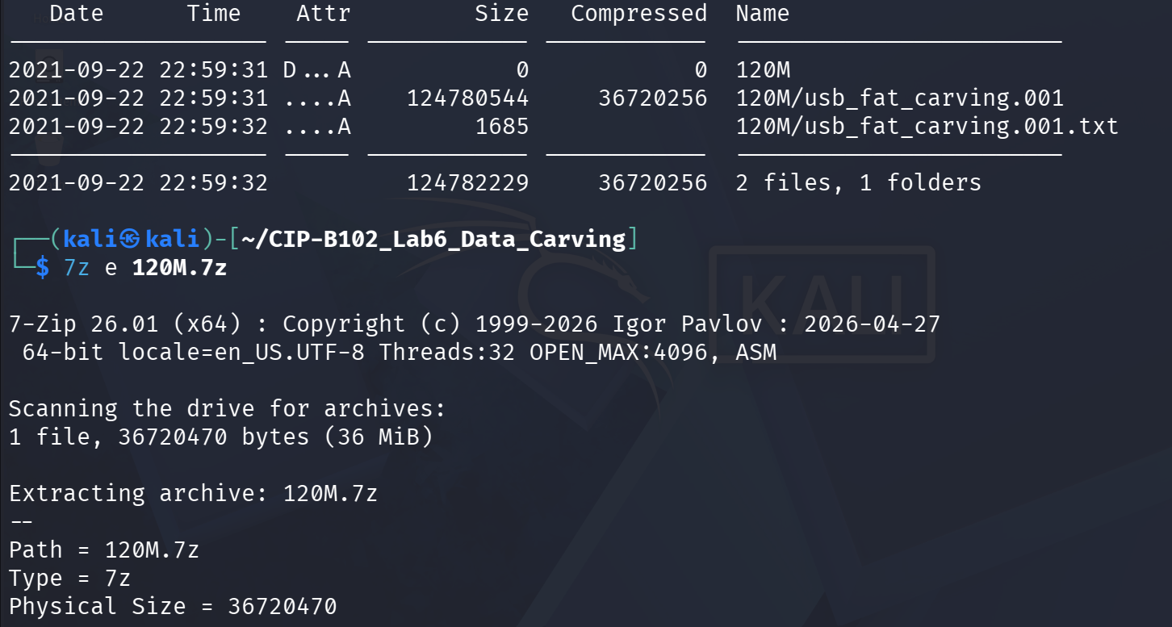
Figure 33. Archive contents confirmed: 120M/usb_fat_carving.001 (124,780,544 bytes) and 120M/usb_fat_carving.001.txt (1,685 bytes); extraction (7z e) started.
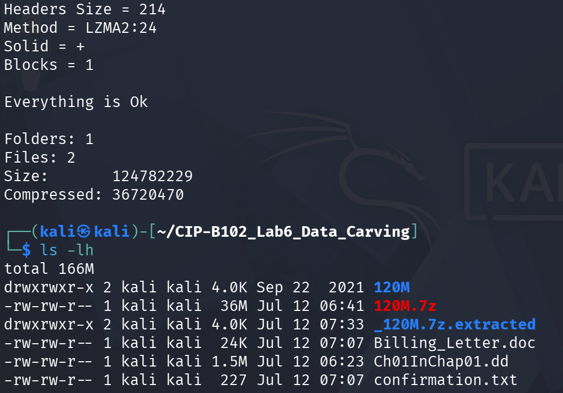
Figure 34. 7z e completed ('Everything is Ok', 2 files extracted) and ls -lh of the working directory showing the newly extracted files.
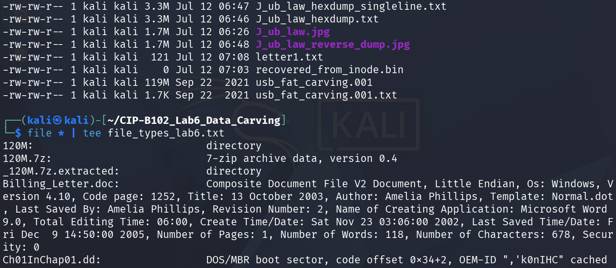
Figure 35. Continued directory listing showing all working files, including the extracted usb_fat_carving.001 (119M).
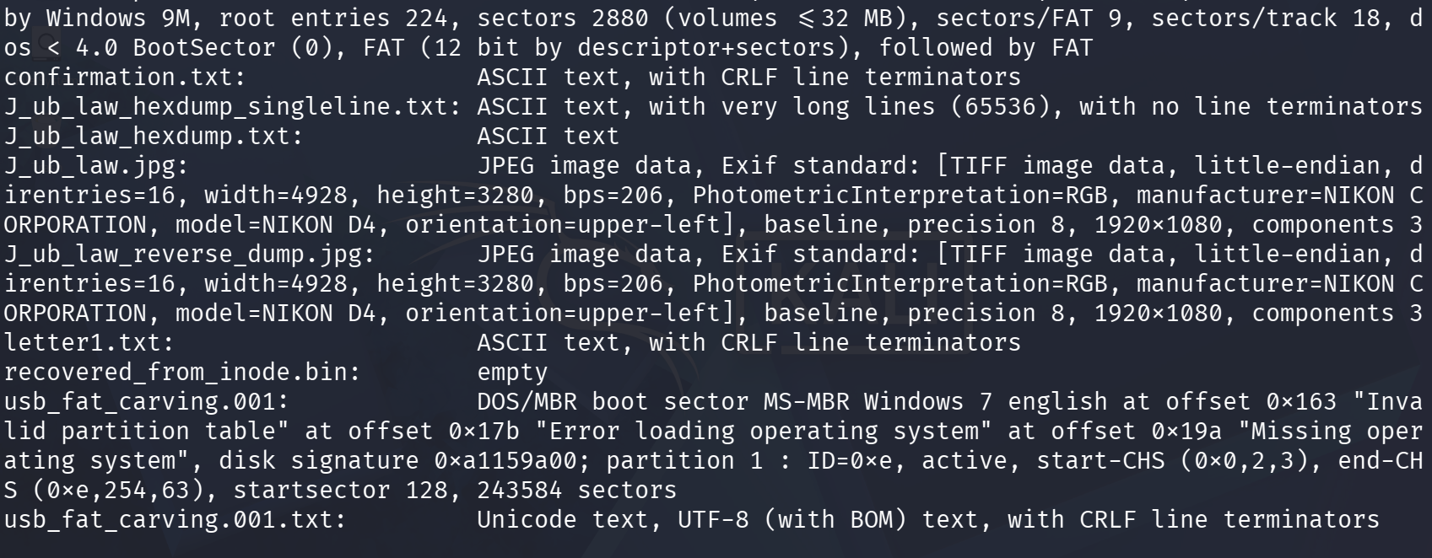
Figure 36. file * output confirming file types for every working file, including usb_fat_carving.001 as a DOS/MBR boot sector with a Win95 FAT16 partition starting at sector 128.
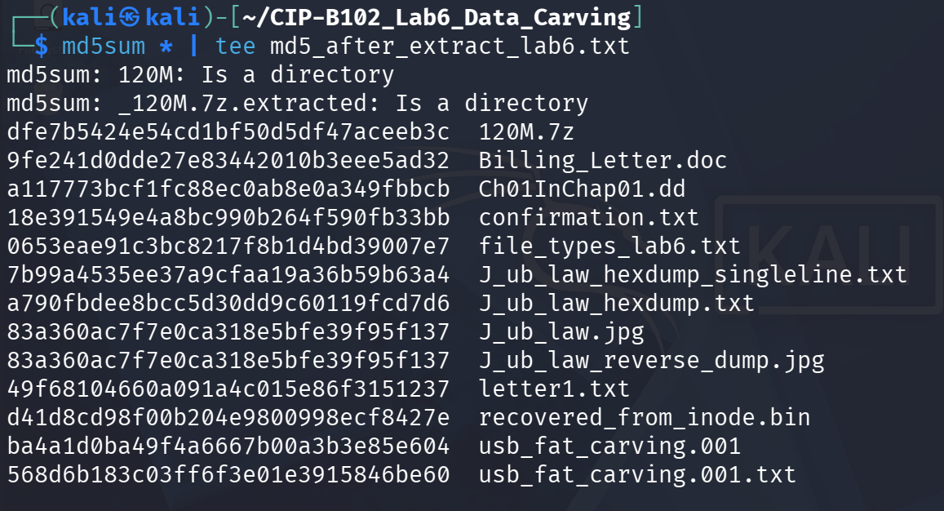
Figure 37. md5sum * output for every file in the working directory, saved to md5_after_extract_lab6.txt for the evidence record.
The extracted image filename matched the slide's usb_fat_carving.001, so it was used directly for the remaining TSK and scalpel steps.
IMAGE="usb_fat_carving.001" ls -lh "$IMAGE" img_stat "$IMAGE" mmls "$IMAGE" fls -o 128 "$IMAGE" fls -o 128 -d "$IMAGE"
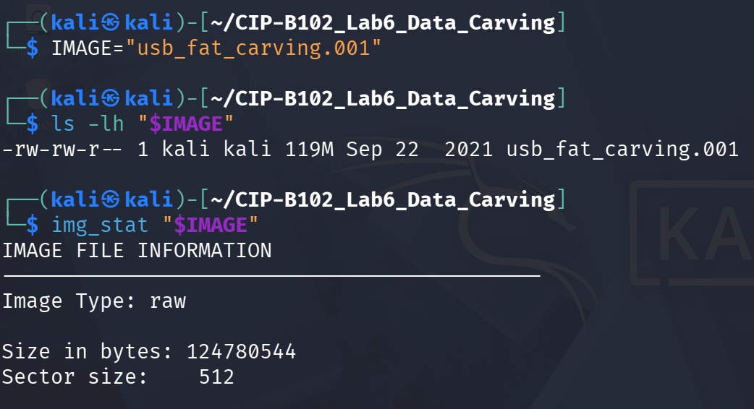
Figure 38. IMAGE variable set to usb_fat_carving.001; img_stat confirming a 124,780,544-byte raw image with 512-byte sectors.
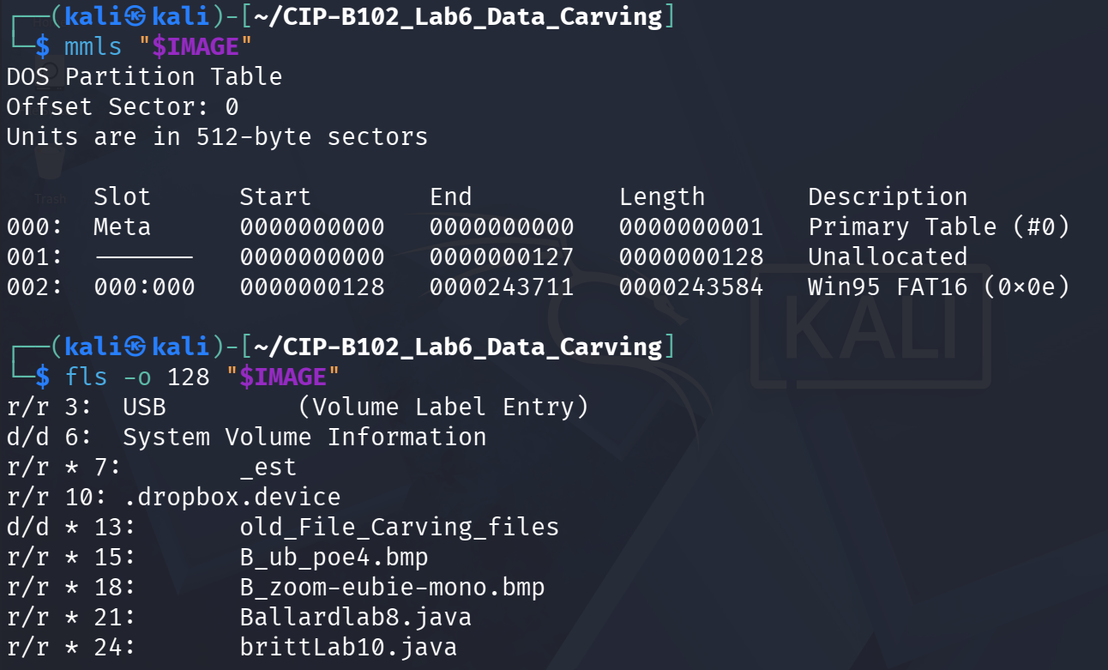
Figure 39. mmls output showing the DOS partition table: a Win95 FAT16 partition beginning at sector 128 (offset used for all subsequent fls commands), and the start of the fls -o 128 file listing.
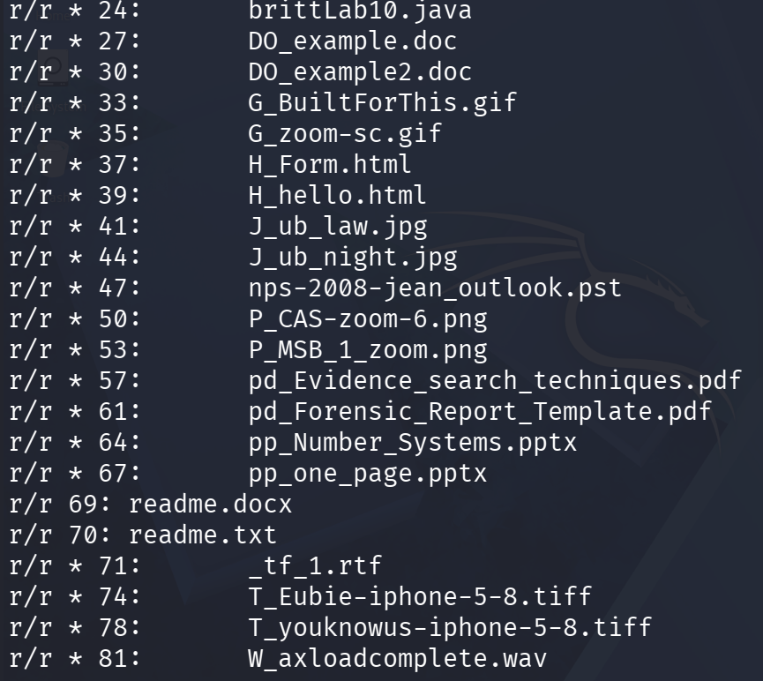
Figure 40. Continued fls -o 128 listing showing dozens of allocated and deleted (marked *) files on the USB volume, including images, documents, and archive files.
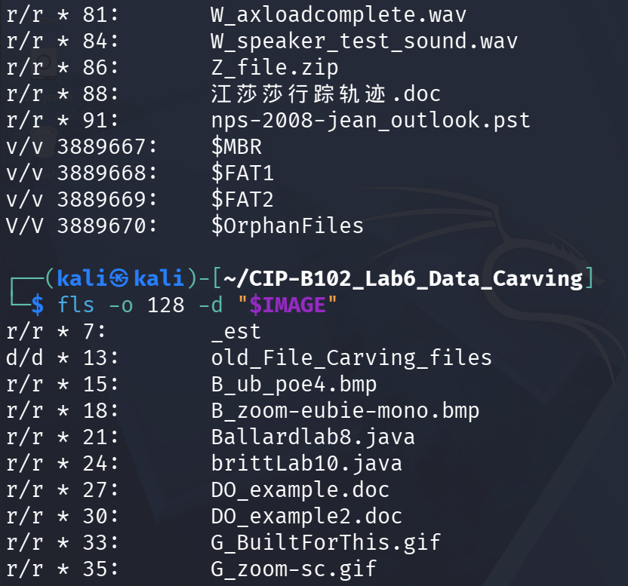
Figure 41. Further fls -o 128 output and the start of fls -o 128 -d, isolating only the deleted entries such as W_axloadcomplete.wav and Z_file.zip alongside FAT system entries ($MBR, $FAT1, $FAT2, $OrphanFiles).
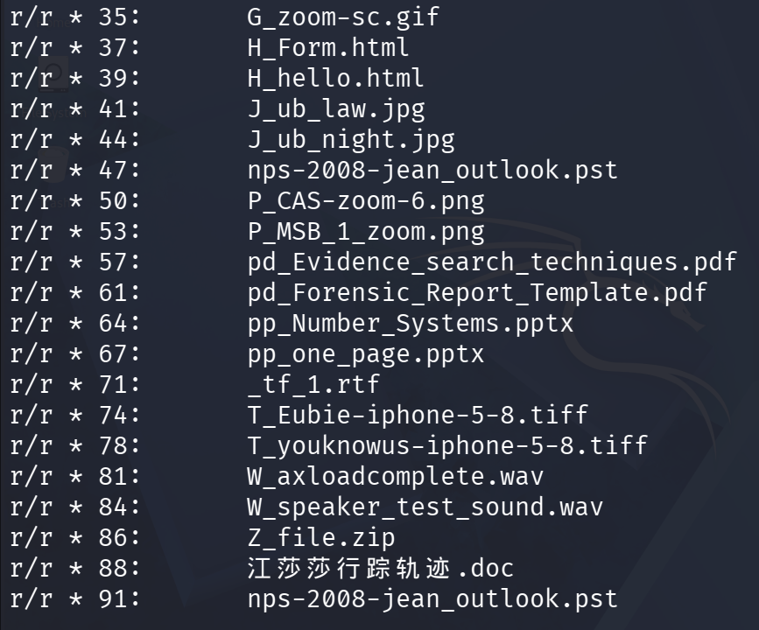
Figure 42. Continued fls -o 128 -d deleted-file listing for the USB volume.
mmls confirmed the USB image contains a single Win95 FAT16 partition starting at sector 128 with a length of 243,584 sectors; the offset of 128 used throughout this lab (and provided in the slide) matches this partition table exactly, so no adjustment was required.

4.8 Part G: Configuring Scalpel and Carving the USB Image

sudo cp /etc/scalpel/scalpel.conf /etc/scalpel/scalpel.conf.bak sudo nano /etc/scalpel/scalpel.conf
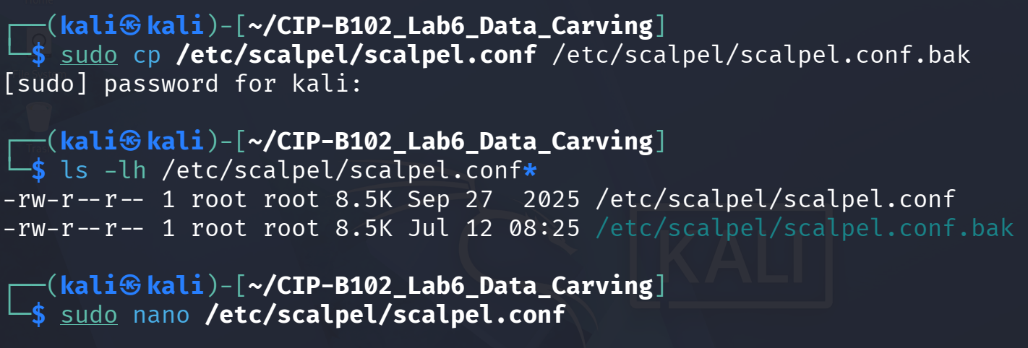
Figure 43. scalpel.conf backed up before editing, and the configuration file opened in nano.
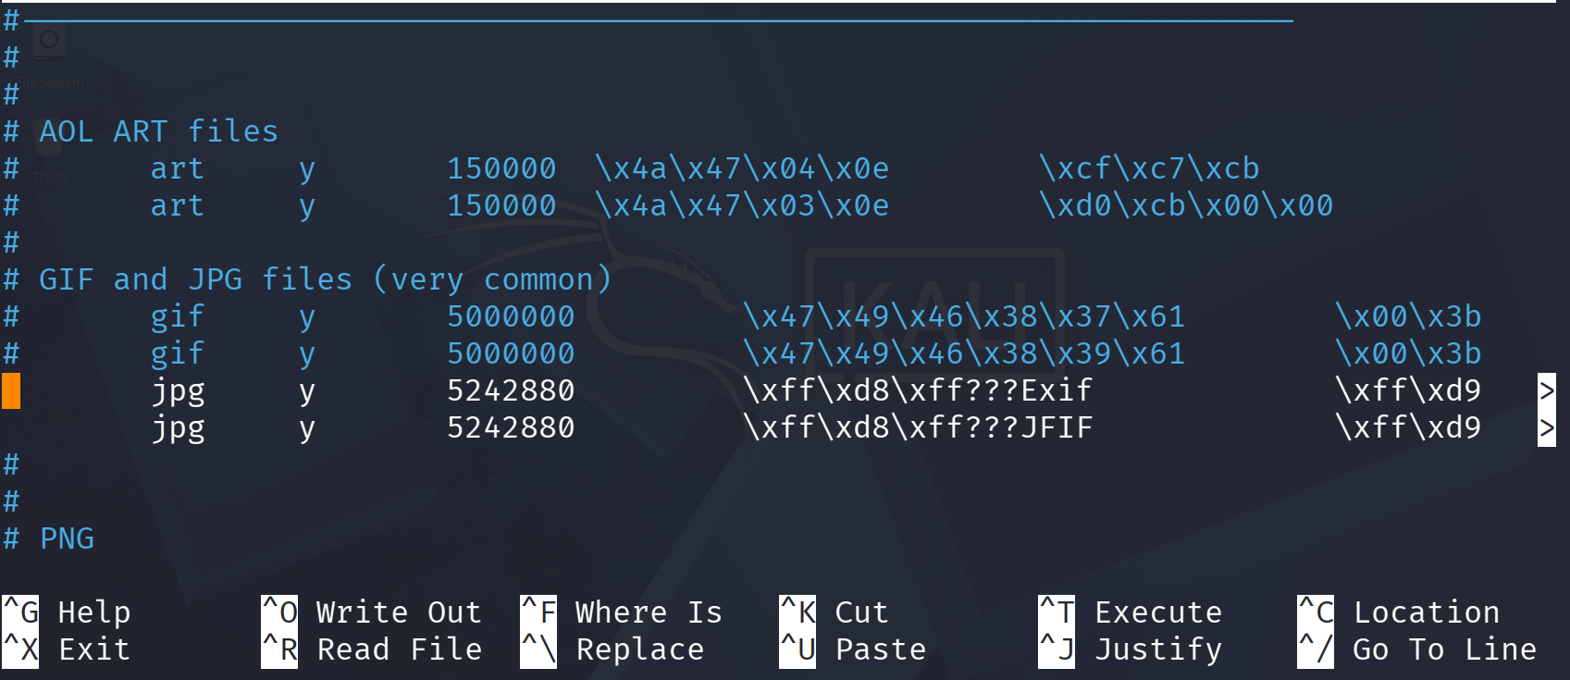
Figure 44. Relevant lines enabled in scalpel.conf: the gif and jpg signature definitions, including the two jpg header/footer patterns (Exif-style and JFIF-style, both terminated by 0xFFD9) used for this lab.
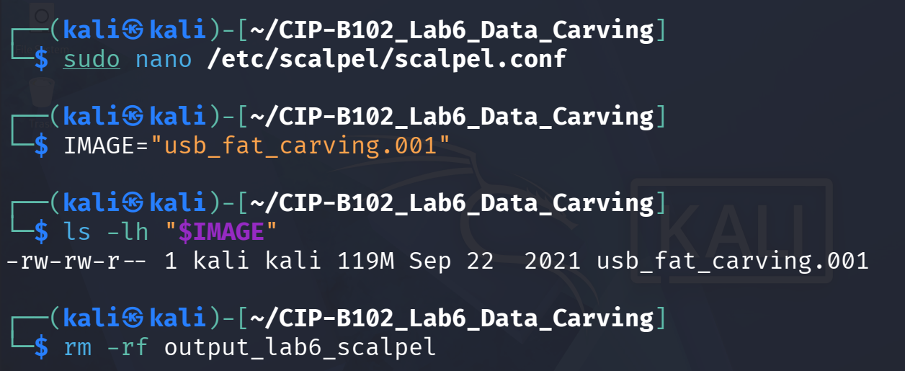
Figure 45. Configuration saved; IMAGE variable re-confirmed; previous output_lab6_scalpel directory removed before the carving run.
scalpel "$IMAGE" -o output_lab6_scalpel
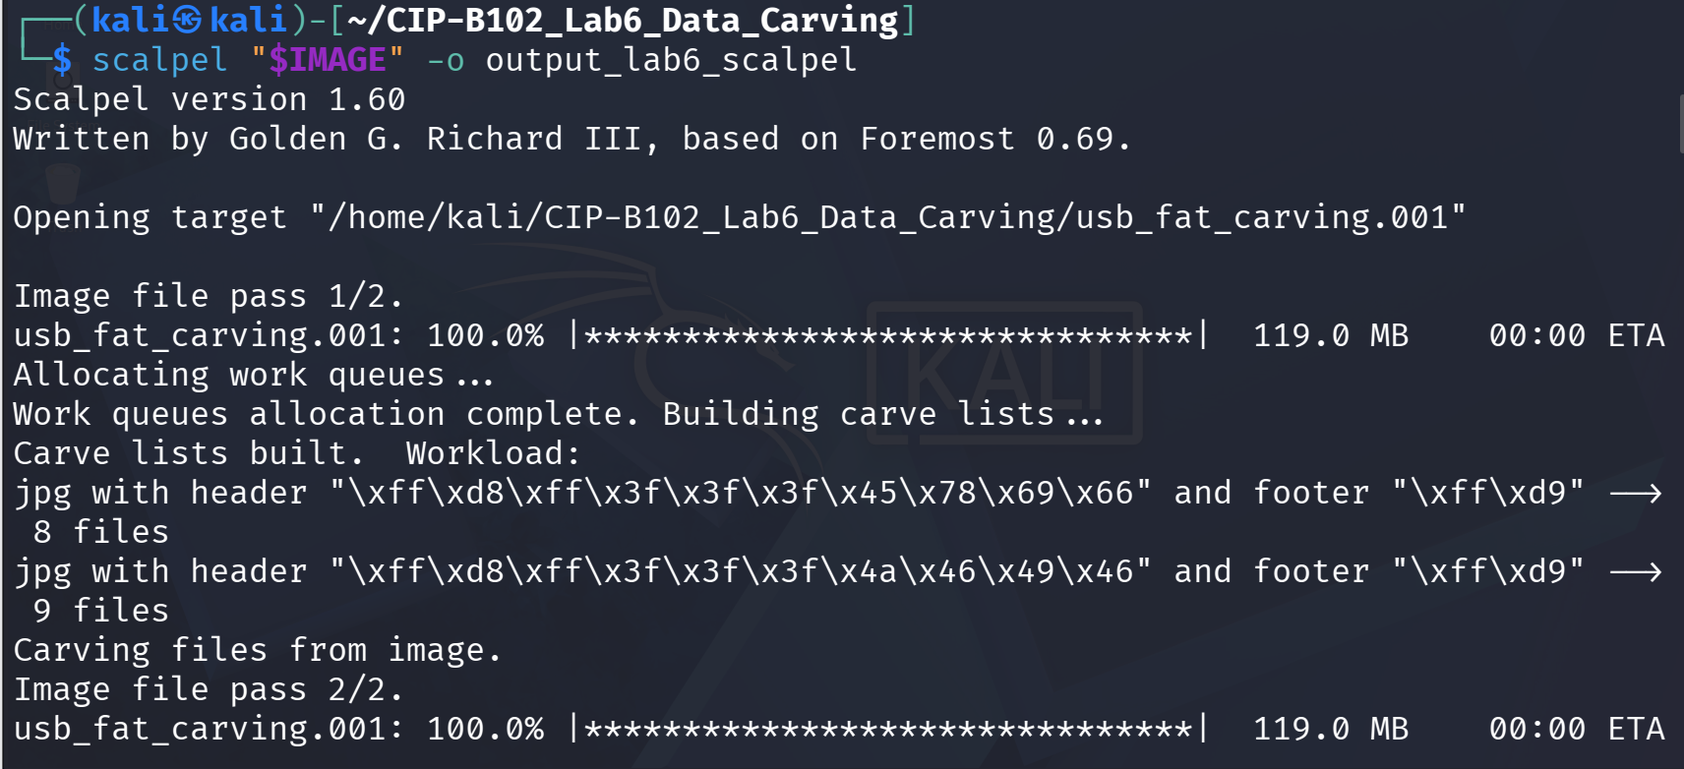
Figure 46. scalpel v1.60 starting the carve: it built two jpg work queues — 8 candidate files matching the Exif-style header/footer and 9 matching the JFIF-style header/footer.
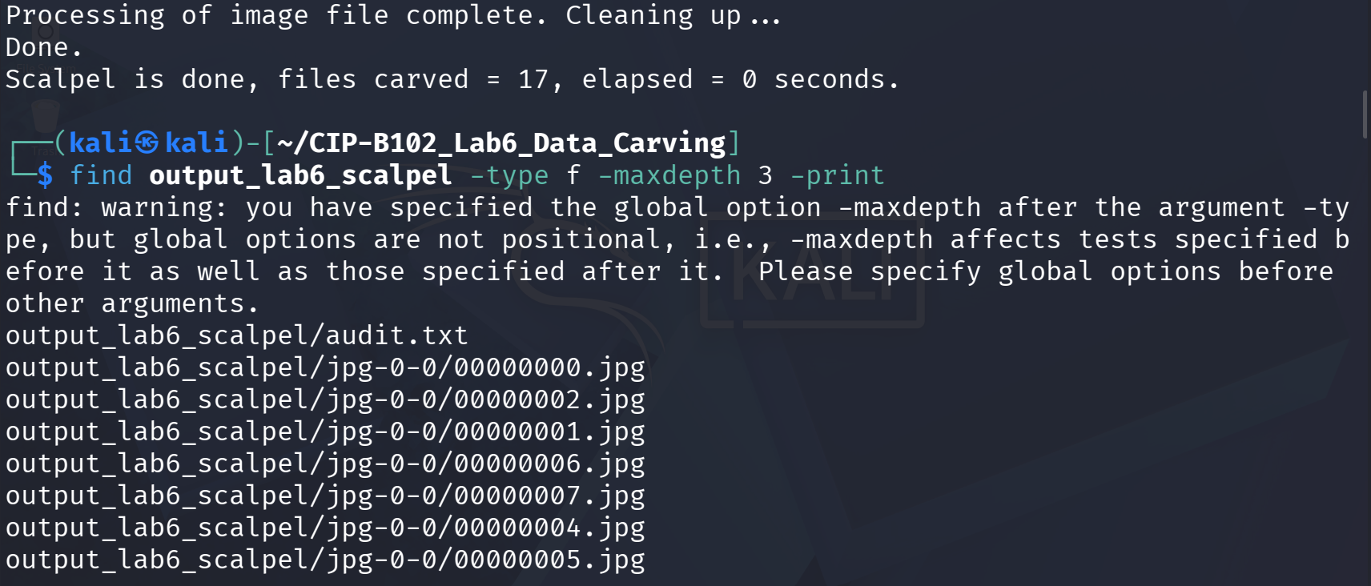
Figure 47. Scalpel completed ('files carved = 17'); find confirming the output structure, including audit.txt and the carved JPGs under output_lab6_scalpel/jpg-0-0/.
cat output_lab6_scalpel/audit.txt | head -80
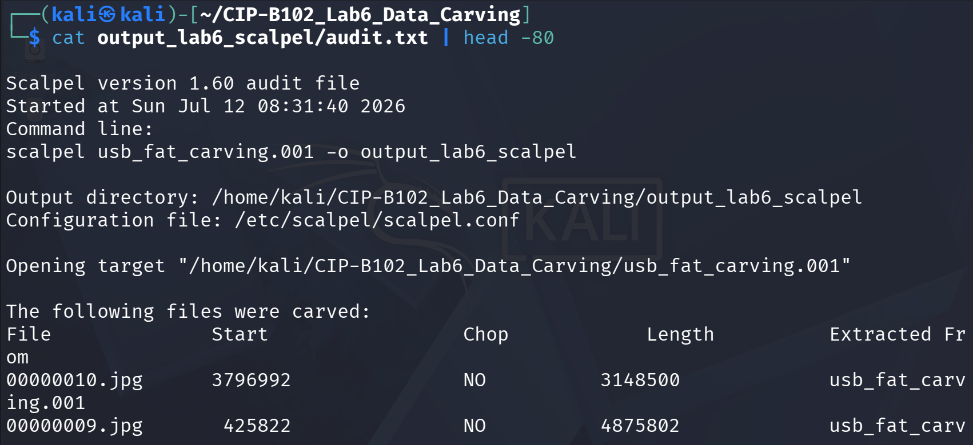
Figure 48. audit.txt header (run timestamp, command line, configuration file used) and the start of the carved-file table (start offset, chop flag, length, source image).
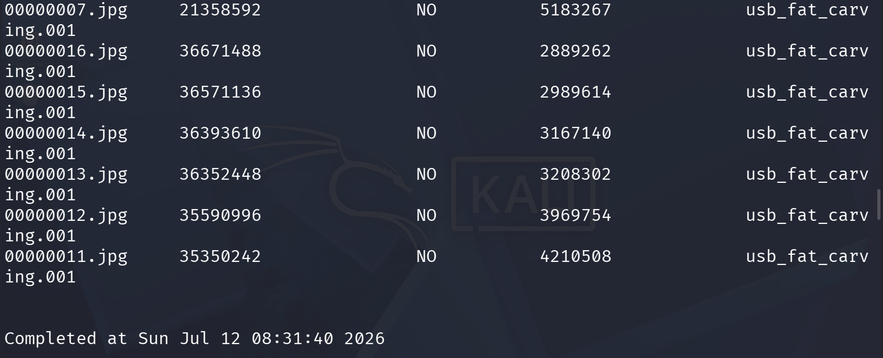
Figure 49. Remaining rows of the carved-file table in audit.txt, listing all 17 carved JPGs with their start offsets and extracted lengths.
find output_lab6_scalpel -type f -exec file {} \; find output_lab6_scalpel -type f -exec md5sum {} \; > carved_files_md5.txt find output_lab6_scalpel -type f \( -name "*.jpg" -o -name "*.JPG" \)
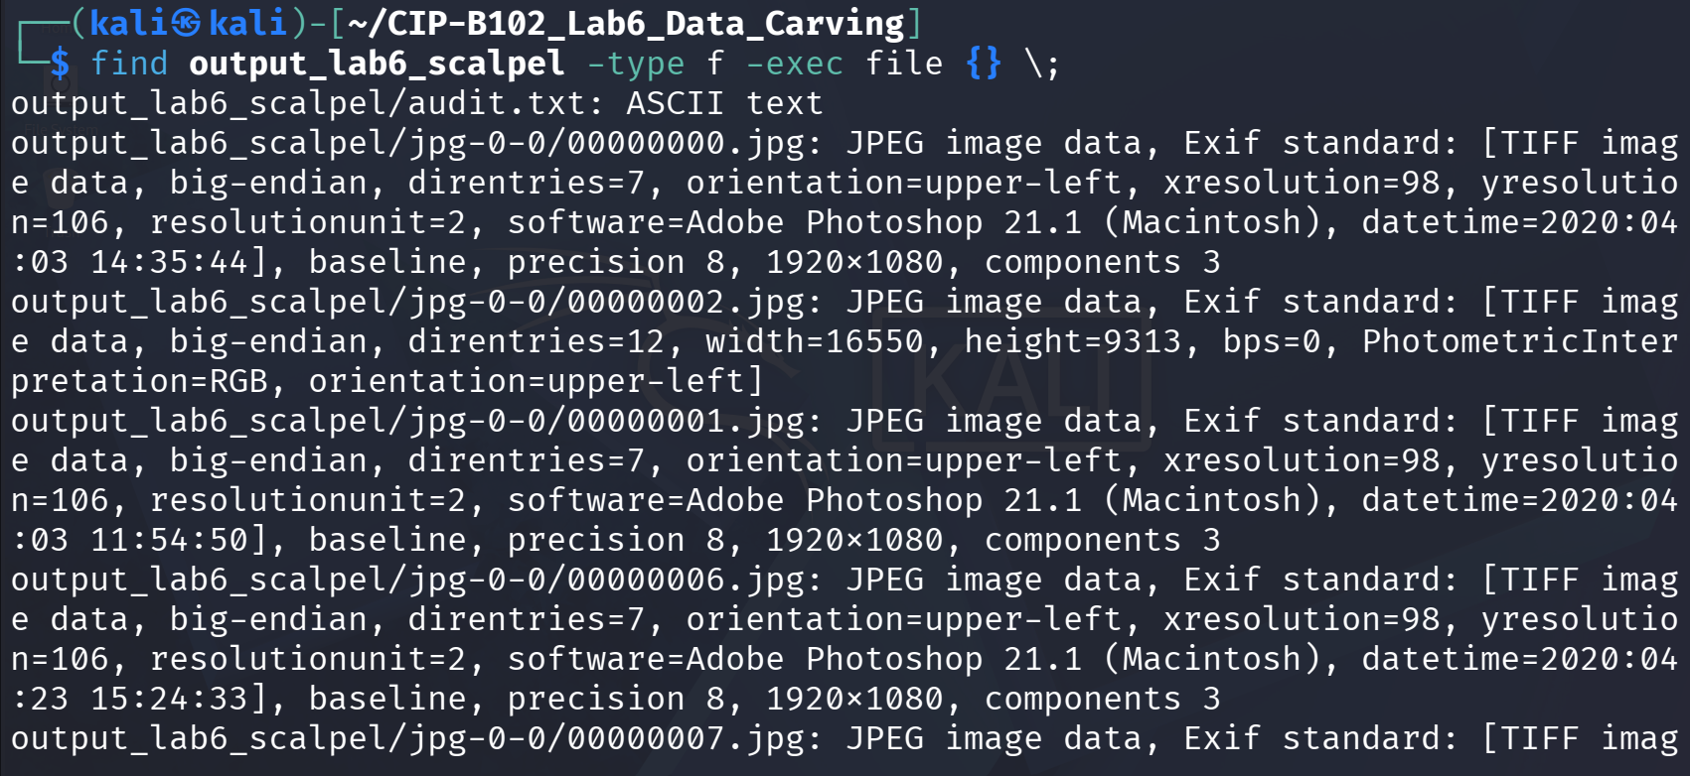
Figure 50. file command confirming several carved outputs as valid JPEG images with Exif/TIFF metadata (e.g., Adobe Photoshop 21.1 software tags and embedded capture dates).
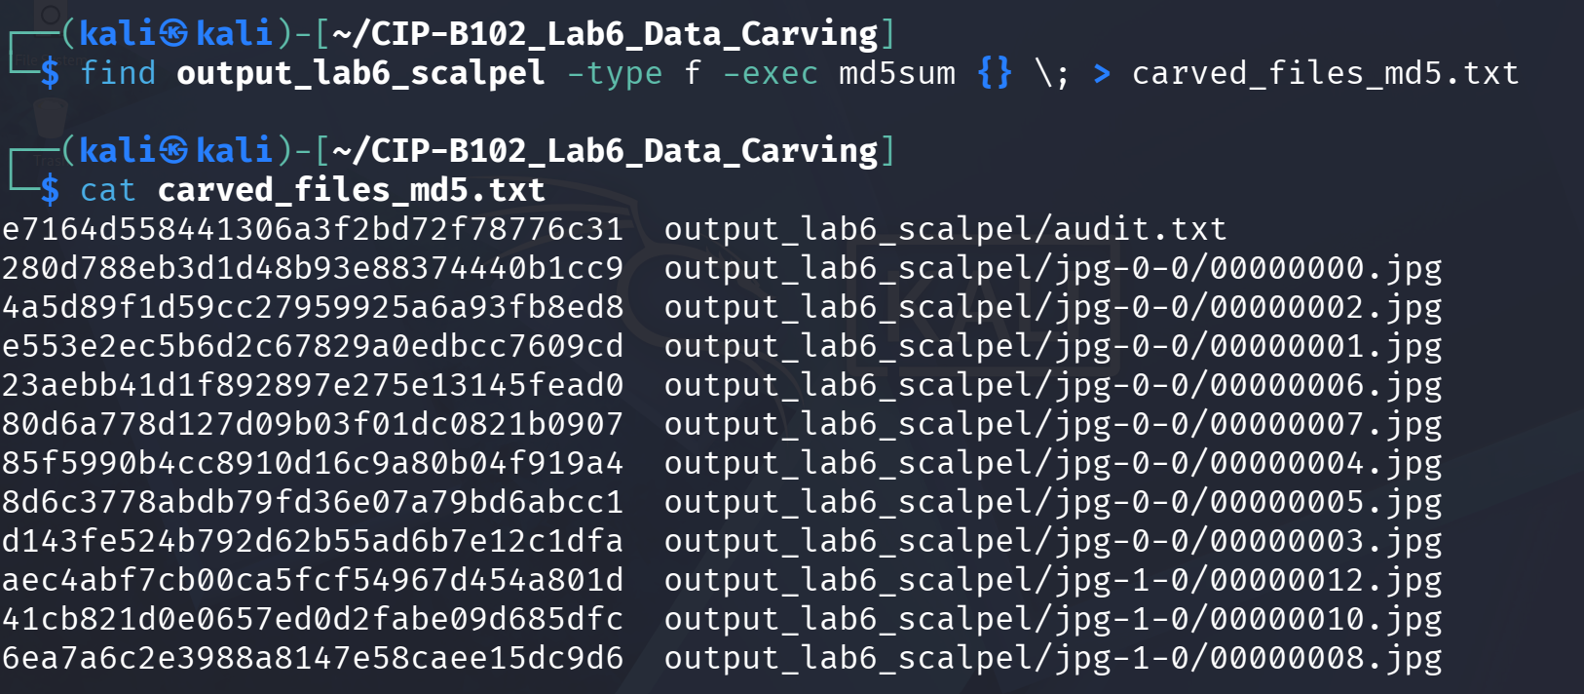
Figure 51. md5sum computed for every carved file and saved to carved_files_md5.txt for the evidence archive.
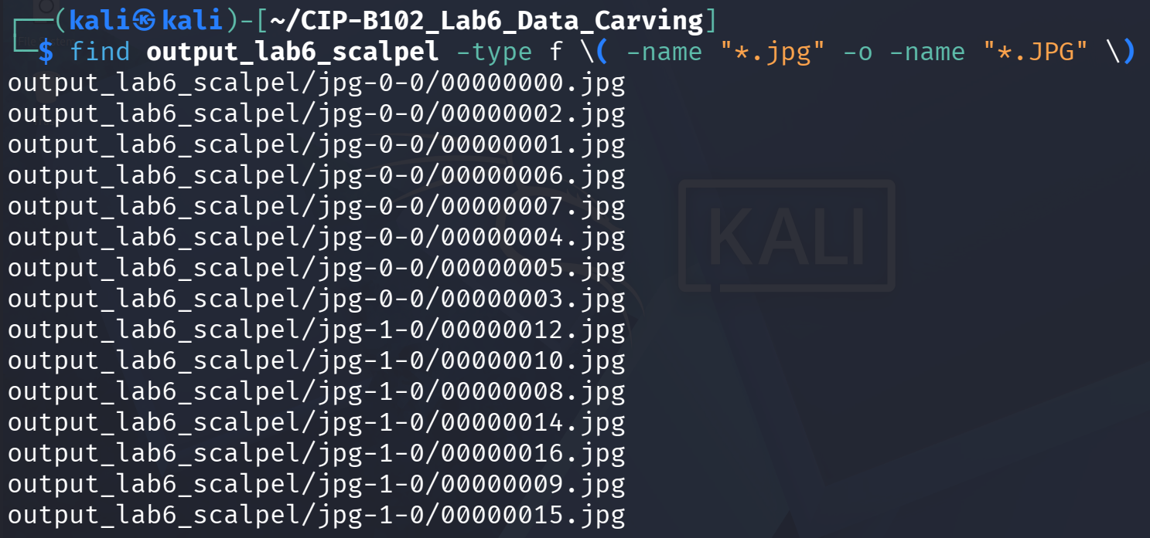
Figure 52. Final find listing of all 17 carved .jpg files across the jpg-0-0 and jpg-1-0 output subfolders.
Visual verification: 00000000.jpg and 00000001.jpg were both confirmed by file as valid, well-formed JPEG images (baseline, 1920x1080, 3 components) and opened correctly in an image viewer. 00000002.jpg was also identified as JPEG image data by file, but reported implausible dimensions (width 16550 x height 9313) a sign of a partially carved or corrupted file, most likely caused by scalpel reaching its configured maximum carve length before the true EOI footer, or by two adjacent JPEGs being carved as one. This is noted under Limitations below.

5. Findings
Finding Item | Student Response
Original evidence file names | Ch01InChap01.dd, J_ub_law.jpg, 120M.7z (120M.7z extracted to usb_fat_carving.001)
Original evidence hash values | See Section 3.1 hash table (MD5/SHA-256 for all three downloaded files)
Partition offset used | 128 sectors (Win95 FAT16 partition confirmed by mmls on usb_fat_carving.001)
Scalpel configuration file types enabled | jpg (two header/footer patterns: Exif-style FFD8FF3F3F3F4578696600...FFD9 and JFIF-style FFD8FF3F3F3F4A46494600...FFD9)
Number of carved files recovered | 17 files (scalpel reported: files carved = 17)
Number of carved JPG files that opened successfully | At least 2 confirmed valid and viewable (00000000.jpg, 00000001.jpg); one additional file (00000002.jpg) carved with implausible dimensions, indicating an incomplete/corrupted carve
Limitations observed | Carved files lost their original names, paths, and timestamps; File_carving.docx was unavailable so the manual dd-offset extraction step was substituted; binwalk reported false-positive signatures inside the 7z LZMA2 stream

6. Validation
Every recovered or reconstructed file in this lab was validated using at least one of: the file command (to confirm the recovered content matches the expected file type/signature), md5sum/sha256sum (to confirm byte-for-byte integrity where an original comparison file existed), and direct visual inspection (opening recovered JPGs in an image viewer).
- The reverse-dumped JPEG (J_ub_law_reverse_dump.jpg) produced an MD5/SHA-256 hash identical to the original J_ub_law.jpg, confirming a lossless hex-to-binary round trip.
- icat-recovered files (Billing_Letter.doc, confirmation.txt, letter1.txt) were each confirmed by file as valid documents/text of the expected type, and their content was readable with cat/a text or document viewer.
- Scalpel-carved JPGs were validated with file, which confirmed valid JPEG/Exif structure for most carved files; two files were opened successfully in an image viewer, while one showed signs of an incomplete carve.
- All working-directory files were re-hashed after extraction (md5_after_extract_lab6.txt) to preserve a complete chain-of-custody record for this lab.

7. Limitations
- Data carving with scalpel recovers file content only; it cannot recover original filenames, folder paths, or file-system timestamps, because that information lives in file-system metadata, not in the byte pattern being carved. All 17 carved files therefore received generic sequential names (e.g., 00000000.jpg).
- File_carving.docx, used in the slide's manual dd-offset extraction demonstration, had no download URL in the slide material and was not available in this environment, so that exact manual step could not be reproduced verbatim; binwalk/dd practice was completed using J_ub_law.jpg and the 120M.7z/usb_fat_carving.001 evidence instead, as permitted by the lab instructions.
- binwalk reported several Zip-archive and JBOOT-style signature matches inside 120M.7z that do not correspond to real embedded files; these are heuristic false positives arising from byte patterns inside the compressed LZMA2 stream, and automatic extraction (binwalk -e) only produced a handful of small unrelated fragments, not the real usb_fat_carving.001 content.
- One scalpel-carved file (00000002.jpg) reported implausible image dimensions, suggesting the carve either ran past the true EOI marker (picking up a length limit or an adjacent JPEG) or captured a truncated/corrupted stream; this is a known limitation of signature-based carving when files are fragmented or stored non-contiguously on disk.
- Only jpg (and optionally gif) signatures were enabled in scalpel.conf for this lab; any other embedded file types present on the USB image outside the enabled signatures would not have been carved.

8. Conclusion
This lab demonstrated the full spectrum of file recovery techniques used in digital forensics, from simple hex-level signature inspection with xxd, through metadata-assisted recovery of deleted-but-still-referenced files with The Sleuth Kit, to true signature-based carving of files with no remaining metadata using scalpel, plus embedded-content discovery with binwalk. The practical difference between these techniques was made clear: TSK's icat/istat could still recover original filenames and timestamps for the deleted entries on Ch01InChap01.dd because their directory entries were merely unallocated, not overwritten, whereas scalpel's byte-pattern carving of the USB image recovered image content with no names or timestamps at all, because it worked purely from JPEG header/footer signatures with no file-system context. Hash verification (md5sum/sha256sum) at each stage confirmed that reconstructed and recovered files were bit-for-bit accurate where a comparison baseline existed. Overall, the lab reinforced why a forensic analyst must document every command, hash value, and configuration choice: carving is a powerful last resort for recovering content, but it cannot substitute for intact metadata when filenames, paths, or timestamps are evidentially important.

9. Reflection (Word Limit: 250 Words)
Data carving cannot always recover filenames and metadata because it works from a fundamentally different layer of the file system than normal recovery. A file system like FAT stores a file's name, size, and timestamps in a separate directory entry, and it stores the file's content in a chain of clusters linked through the File Allocation Table. When a file is deleted, the operating system typically frees the directory entry and FAT chain but leaves the cluster data untouched until it is overwritten. Tools like TSK's icat and istat can still recover names and timestamps in this situation, as seen in this lab with Billing_Letter.doc and confirmation.txt, because the directory entry itself, though marked unallocated, was still present and intact.
Carving tools such as scalpel work differently: they scan raw, unstructured bytes for recognizable header and footer signatures (such as JPEG's FFD8 and FFD9) with no reference to any file system at all. This is what makes carving so powerful, since it can recover data from formatted drives, corrupted file systems, or unallocated space where no directory entries survive; but it is also why carving can never reconstruct a name, path, or timestamp, since none of that information is encoded in the file's raw content. This lab illustrated the contrast directly: all 17 JPEGs carved from the USB image by scalpel received generic numbered names with no original metadata, while files recovered by TSK from the still-intact FAT directory entries kept their real names and timestamps. Analysts must therefore treat carved evidence as content-only and corroborate identity, ownership, or timing through other means whenever possible.

10. Deliverables Checklist
- PDF/Word lab report (this document) CIP-B102_Lab6_[Firstname]_[Lastname]
- ZIP archive containing recovered/carved files: Billing_Letter.doc, confirmation.txt, letter1.txt, J_ub_law_reverse_dump.jpg, and the output_lab6_scalpel/ folder (17 carved JPGs + audit.txt)
- Hash text files: md5_after_extract_lab6.txt, carved_files_md5.txt, file_types_lab6.txt
- Command log/appendix all commands used are included inline throughout Section 4 above
- This reflection (Section 9, ≤250 words)

